ELEMENTARY K-5th grade: 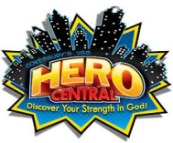
Summer Sunday Bible Fun – We will meet in the purple room at the 10:30am service on all Sundays in July.
Spark – We are on summer break until August 24th.
VBS – Registration is NOW OPEN!!! You may register up until the first day of VBS. Cost is $30 per child with $10 off for each additional child. You may register in the church office Monday – Friday 9am-3pm or on our church website which is svlcsimi.com and go to youth ministries to the pay online here tab.
Save The Dates: VBS: July 17th – 21st (Hero Central) & Summer Camp: July 23rd – 28th. For those going to summer camp who need a ride, we will meet at the church on Sunday, July 23rd at 1pm.
MIDDLE SCHOOL 6th-8th grade:
Acolytes – Summer acolytes started on May 28th and will continue through August 20th.
Pool Party – We will meet at 6404 White St, Simi Valley 93063 to go swimming and have some snacks from 7:30-9pm on Thursday, July 13th.
Save The Dates: VBS: July 17th – 21st (Hero Central) – Please let Marc know if you can volunteer & Summer Camp: July 23rd – 28^{th.} For those going to summer camp who need a ride, we will meet at the church on Sunday, July 23rd at 1pm.
HIGH SCHOOL 9th-12th grade: 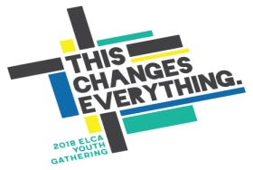
Youth Group – Youth group will resume on August 17th.
Pool Party – We will meet at 6404 White St, Simi Valley 93063 to go swimming and have some snacks from 7:30-9pm on Thursday, July 13th.
Houston National Youth Gathering Parent’s Meeting – We will be having a meeting regarding the National Youth Gathering in Houston on Sunday, August 13th at 11:30am-12:30pm in the youth room at church for parents who were not able to go to the meeting in early June. All incoming 9th graders through 12th graders may attend this event which will take place June 27th through July 1st 2018 in Houston. Deposit of $150 is due by August 15th to hold a spot for the National Youth Gathering.
Save The Dates: VBS: July 17th – 21st (Hero Central) – Please let Marc know if you can volunteer.
College /Young –adult:
College/Young Adult Group – We are on break until August. Please contact Amanda Lembke at amandalembke@hotmail.com for more information.
Save The Dates: VBS: July 17th – 21st (Hero Central) – Please let Marc know if you can volunteer.

