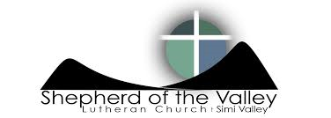
ELEMENTARY K-5th grade: 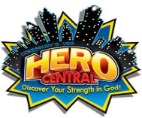
Summer Sunday Bible Fun – Summer Sunday Bible Fun starts on June 4th @ 10:30am. We will meet in the purple room. We will NOT have SSBF on June 25th.
Spark – The last Spark for the school year will take place on June 8th at Big Z’s from 6:30-7:45pm. We will NOT meet on June 1st. We will resume Spark on August 24th.
Church Picnic & Service – We will meet at Santa Susana Park on Katherine Rd. at 10:30am. Picnic and games following the service at the park.
VBS – Registration will is NOW OPEN!!! Early Bird pricing will be available until June 26th.
Save The Dates: VBS: July 17th – 21st (Hero Central) & Summer Camp: July 23rd – 28th
MIDDLE SCHOOL 6th-8th grade:
Acolytes – Summer acolytes started on May 28th and will continue through August 20th.
Bowling – We will meet at Harleys Valley Bowl on Cochran and Stearns across from Simi High on June 8th from 8-10pm. Cost is $10.
Houston National Youth Gathering Parent’s Meeting – We will be having a meeting regarding the National Youth Gathering in Houston on Tuesday, June 6th at 7pm-8pm in the youth room at church. All incoming 9th graders through 12th graders may attend this event which will take place June 27th through July 1st 2018 in Houston.
Save The Dates: VBS: July 17th – 21st (Hero Central) & Summer Camp: July 23rd – 28th
HIGH SCHOOL 9th-12th grade: 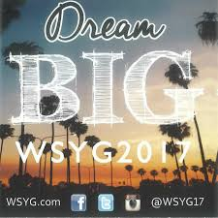
Youth Group – The last regular youth group of the summer will take place on June 8th at Harleys Valley Bowl from 8-10pm. Cost is $10. We will NOT meet for youth group on June 1st. After June 8th we will meet once in July and we will resume on August 17th.
Houston National Youth Gathering Parent’s Meeting – We will be having a meeting regarding the National Youth Gathering in Houston on Tuesday, June 6th at 7pm-8pm in the youth room at church. All incoming 9th graders through 12th graders may attend this event which will take place June 27th through July 1st 2018 in Houston.
Western States Youth Gathering – This event will be held at California Lutheran University June 28th – July 2nd.
Save The Dates: VBS: July 17th – 21st (Hero Central) – Help Volunteer
College /Young –adult:
College/Young Adult Group – Sunday, June 11th and June 25th at Amanda and Neal Lembkes house from 8-10pm.
Save The Dates: VBS: July 17th – 21st (Hero Central) – Help Volunteer

