

**[Like us on Facebook](https://www.facebook.com/SVLCSimi/)**  
f

**April**

**2017**

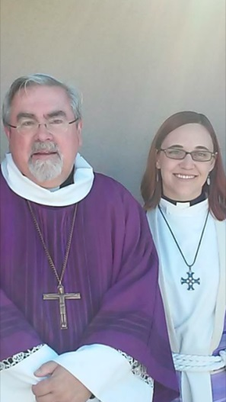

“The Most Holy Time”

by Pastor Jennifer (with gratitude to my colleague, Pastor Elizabeth Nees)

Holy Week is the period of the church year from Palm Sunday until Easter Sunday. These days are at the heart of the Christian story, the Christian faith, the Christian life.  We gather to hear the story of Jesus’ arrest, crucifixion, death, and resurrection, a story that is at the heart of our identity as a community of faith. It is important for us to hear this story—this whole story—as a community. We trust that the Spirit calls us together and transforms us in the hearing of the story.

But as a community we also enact the story of Holy Week. We shout “Hosanna” and wave palm branches on Palm Sunday, we receive the meal Christ offers his followers on Maundy Thursday, we pause at the foot of the cross on Good Friday and finally we shout aloud that “Christ is risen indeed!” We hear and enact the story of this holiest of weeks trusting that this is not only a story of history, but that God is with us now, doing the same things with and for us.

Palm/Passion Sunday—A day of irony. The service begins with a palm procession reminding us of Jesus’ triumphant entry into Jerusalem, honored as a Messiah and a king. The crowds shouted “Hosanna in the highest!” as they joyfully welcomed Jesus into their midst, and so will we. But as the service continues, we will hear how Jesus was seen as a threat to the established order, how the religious leaders conspired to have him killed, and how one of his own disciples agreed to betray him. In just a matter of days, the crowds will change their shouts of “Hosanna!” into cries of “Crucify him!”

Maundy Thursday—At the heart of Maundy Thursday is the command to love one another. (The word ‘Maundy’ comes from the Latin word ‘mandatum,’ which means ‘command.’ It refers to Jesus’ words to his disciples: “A new commandment I give to you, that you love one another.”) On this night, we remember Jesus’ Last Supper with his disciples, his final words to them before he is arrested and sent to the cross. We end the Maundy Thursday service with the complete stripping of the altar as we remember Jesus’ clothes taken from him. This will also serve as a stark contrast to Easter morning when the space is filled again with signs of new life, joy and victory.

Good Friday—At the heart of the Good Friday liturgy is the passion narrative, the story of Jesus’ arrest, trial, suffering, and death. At the noon service, we will hear the passion according to Matthew, and will partake of communion with vinegar instead of wine, remembering that Jesus was given vinegar to drink while on the cross. At the 7:00 service, we will hear the passion according to John as candles are extinguished and darkness encroaches. While the tone of Good Friday is somber, this day is ultimately good. We know that this day is good because we already know the end of the story. We already know that this death will end in life; life for us, life for the world. On this day we see God’s extravagant love for us and the world.

Resurrection of our Lord—On this day the Lord has acted! On the first day of the week God began creation, transforming darkness into light. On this day, Jesus Christ was raised from the dead. We gather on Sunday, the first day of the week, to celebrate, give thanks and be encountered by God, who rose from the dead and gave life to the world. We celebrate this new creation in the waters of baptism and in the meal set before us. On Easter Sunday we celebrate with great joy this day of days, and we begin the great fifty days of the Easter season. Filled with hope, we go forth to share the news that Christ is risen.

You are invited to hear, enact and be fed by this Holy Week. Come hear the story, enact what these days mean for us, and receive the presence of a God who has won over death.

Yours in Christ,

Pastor Jennifer Chrien

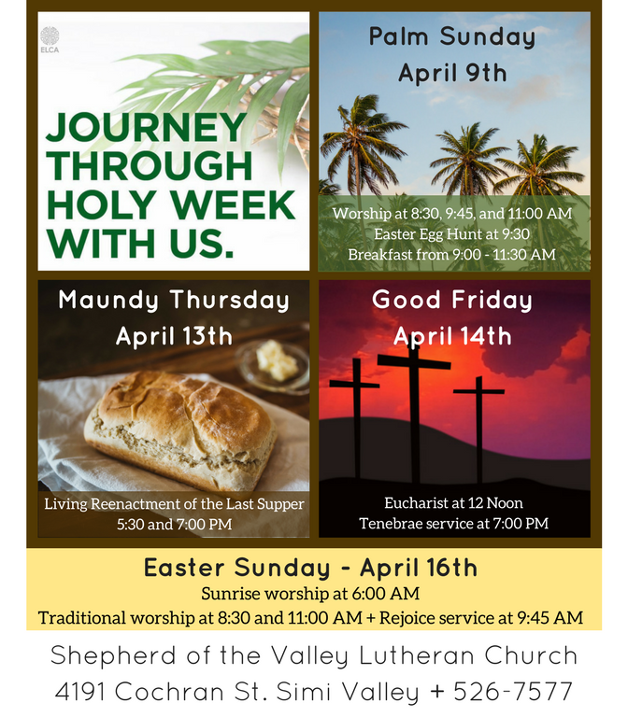

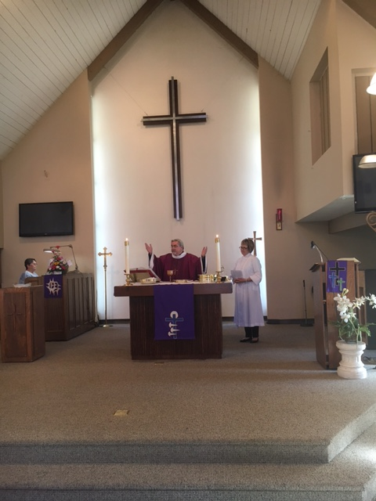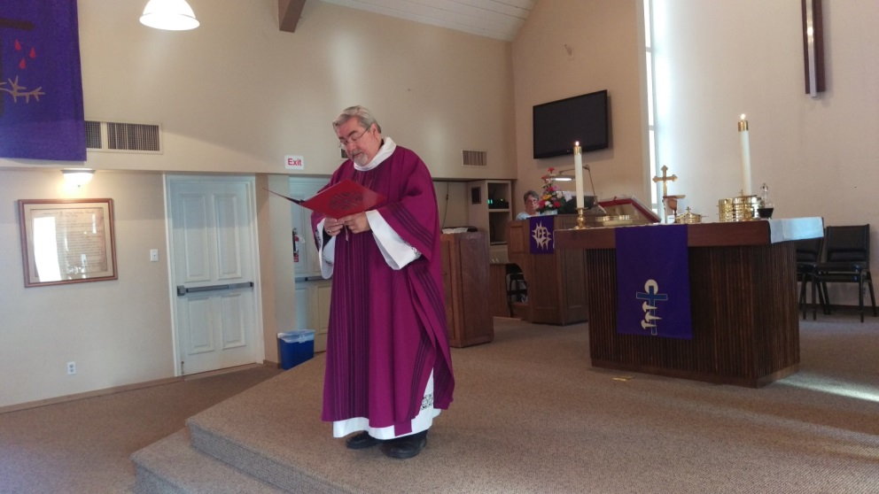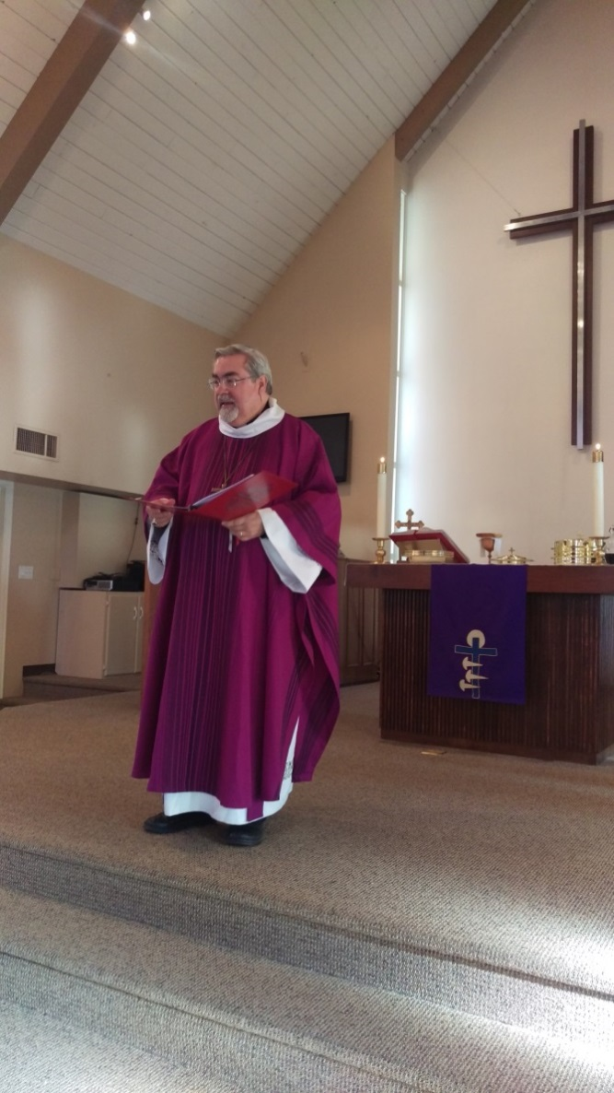

*"Shepherd of the Valley welcomed Southwest California Synod Bishop Guy Erwin to worship on March 19th. Bishop Guy preached at all three services and brought greetings on behalf of the Synod, which stretches from Long Beach up to Kern County, and up the coast as far as San Luis Obispo.*

*Bishop Guy was elected in 2013 to a six-year term as the Bishop of the Southwest California Synod. Prior to his election as Bishop, he served as the Gerhard and Olga Belgum Professor of Lutheran Confessional Theology at California Lutheran University. Bishop Guy was the first openly gay Bishop elected in the ELCA, and is also a member of the Osage Nation.*

*Thank you for your visit to Shepherd of the Valley, Bishop!"*

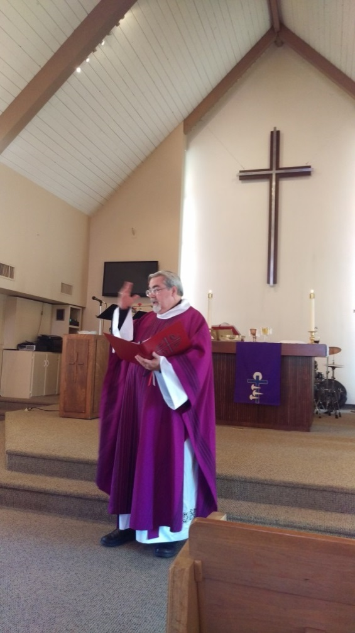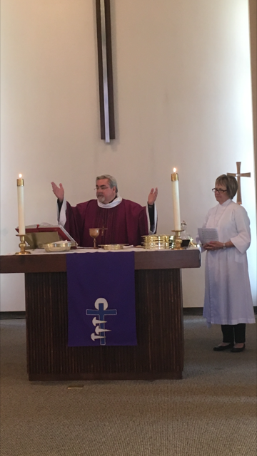

**Ashes To Go video**

**Lenten Bible Study**

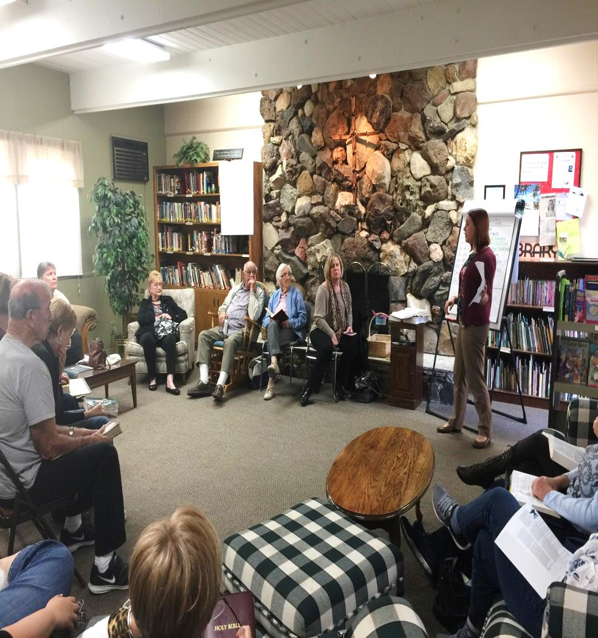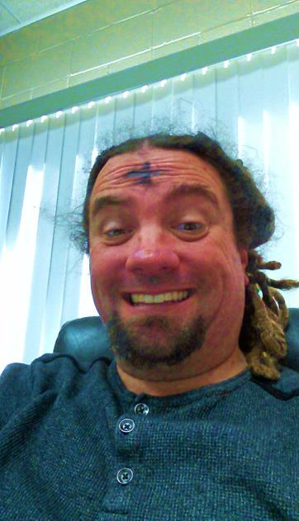

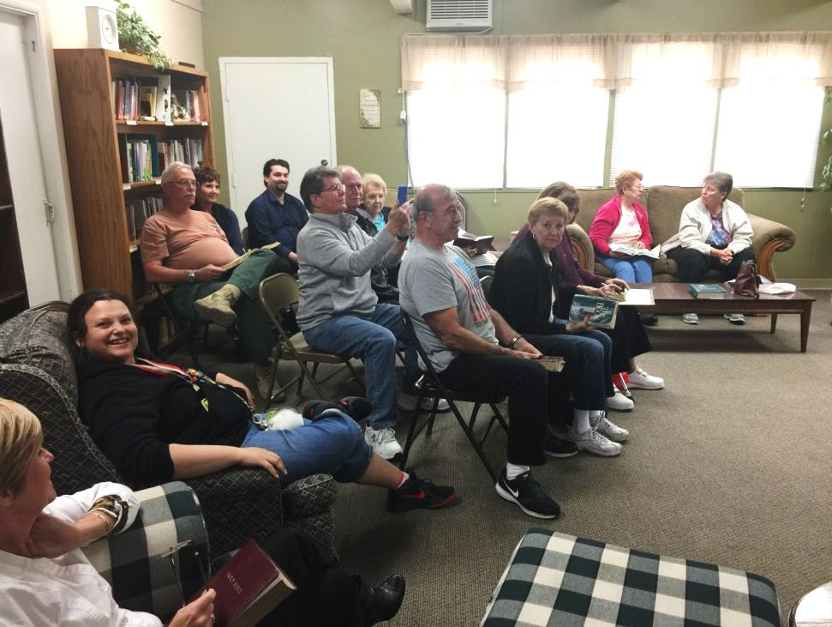

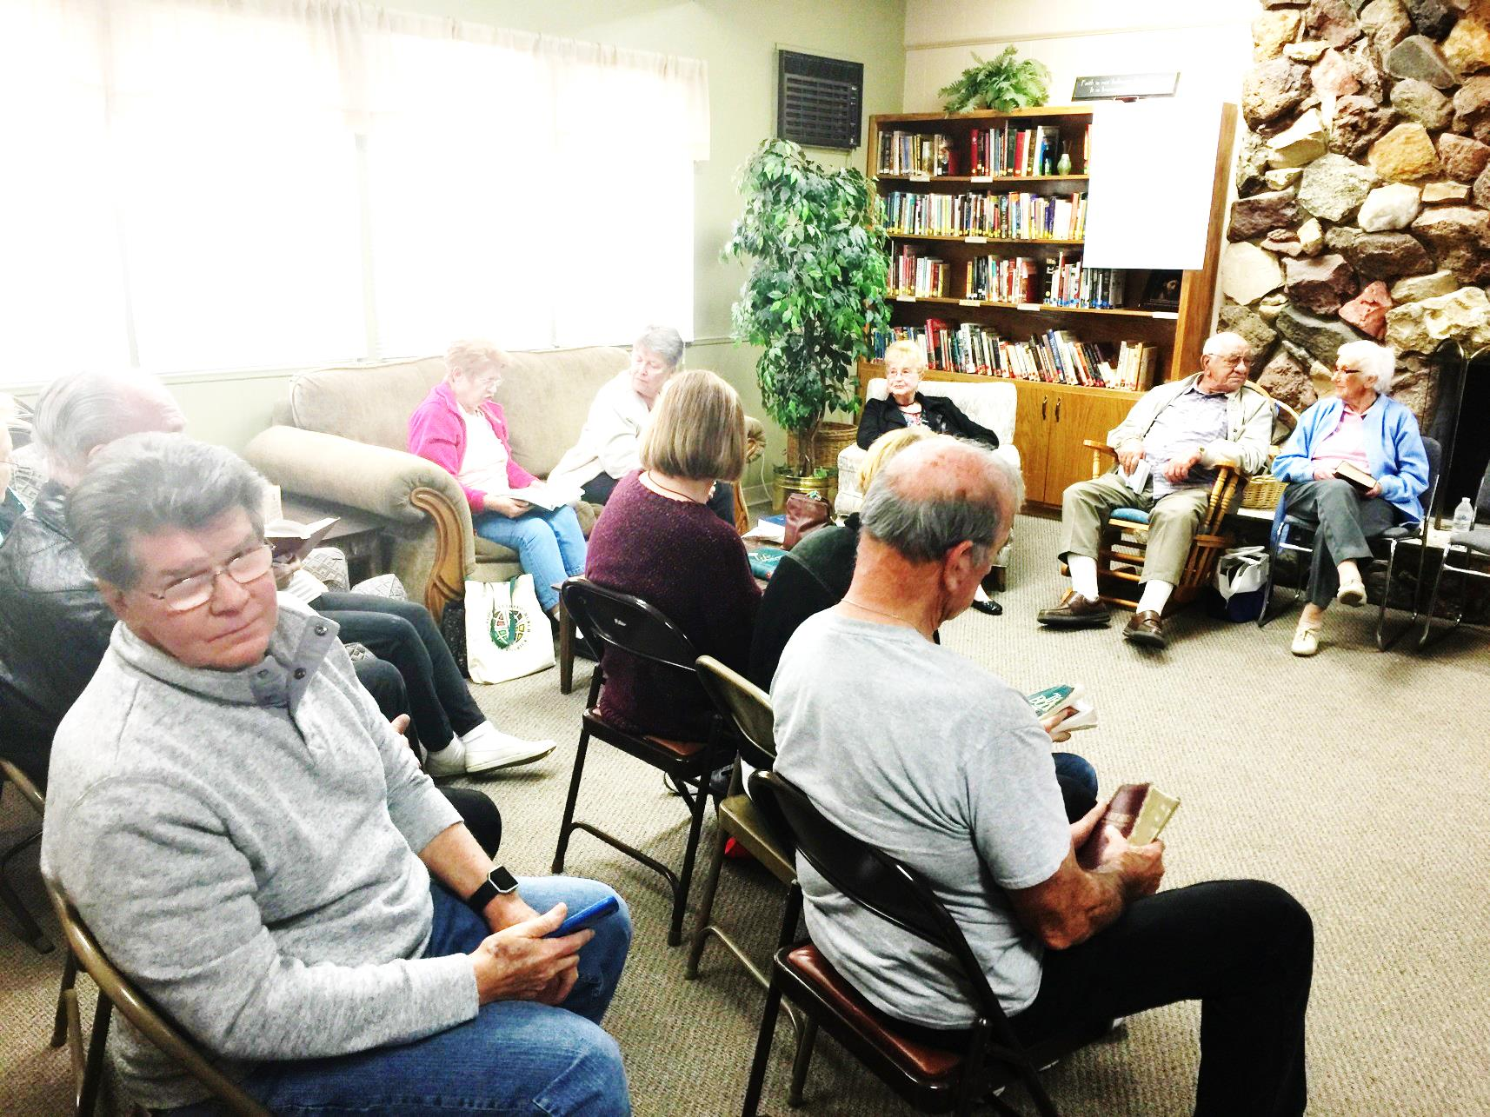

This is the look I get when I ask for too many pictures

**Lenten Soup Supper**

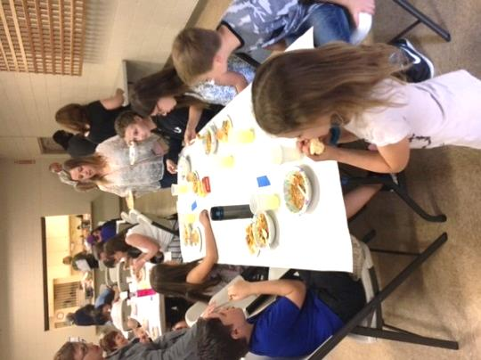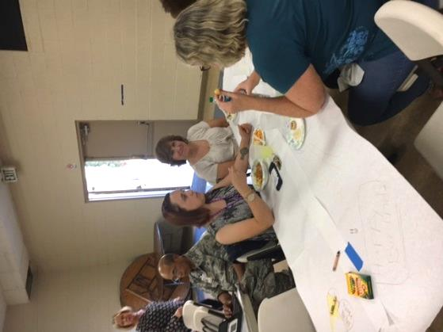

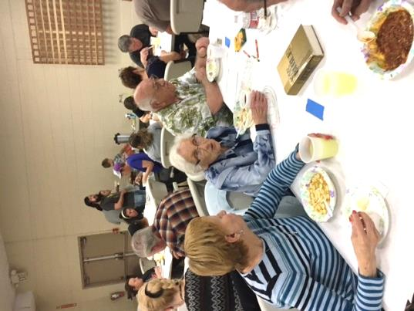

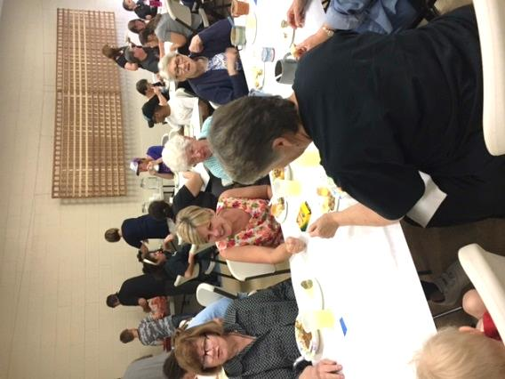

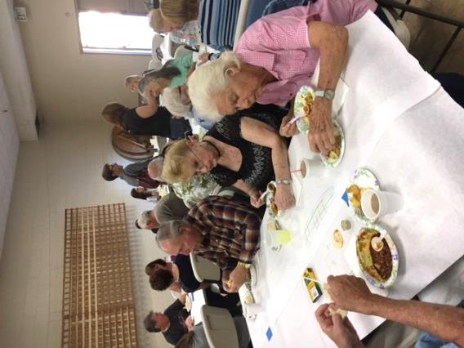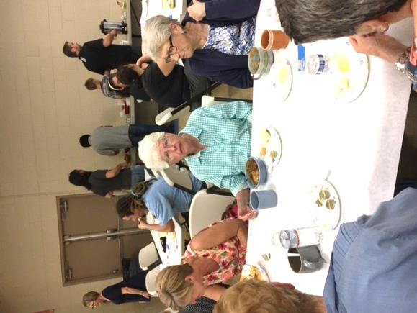

**THE COMPASSION EXPERIENCE**

*The youth had the opportunity to go to The Compassion Experience on Sunday, March 19th. We were able to listen and see how children from different countries are living in poverty and what we can do to help.*

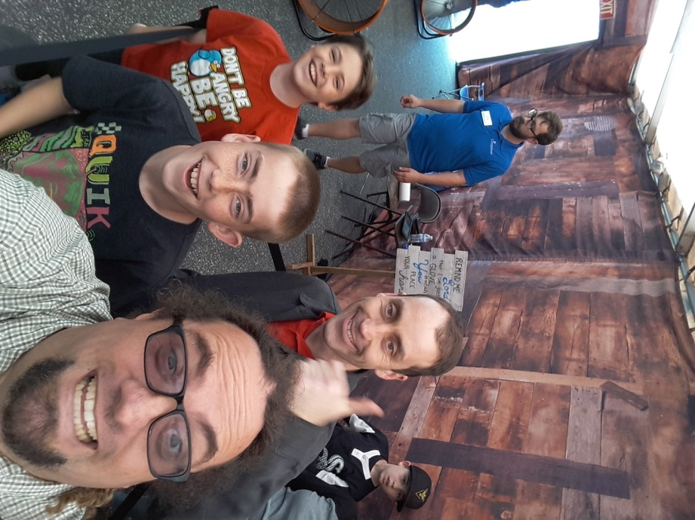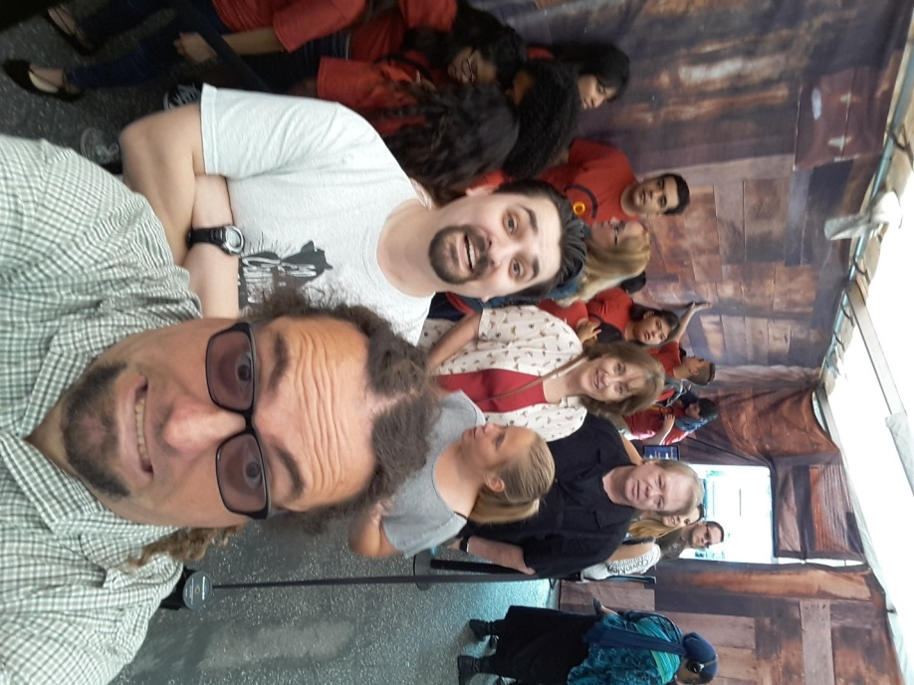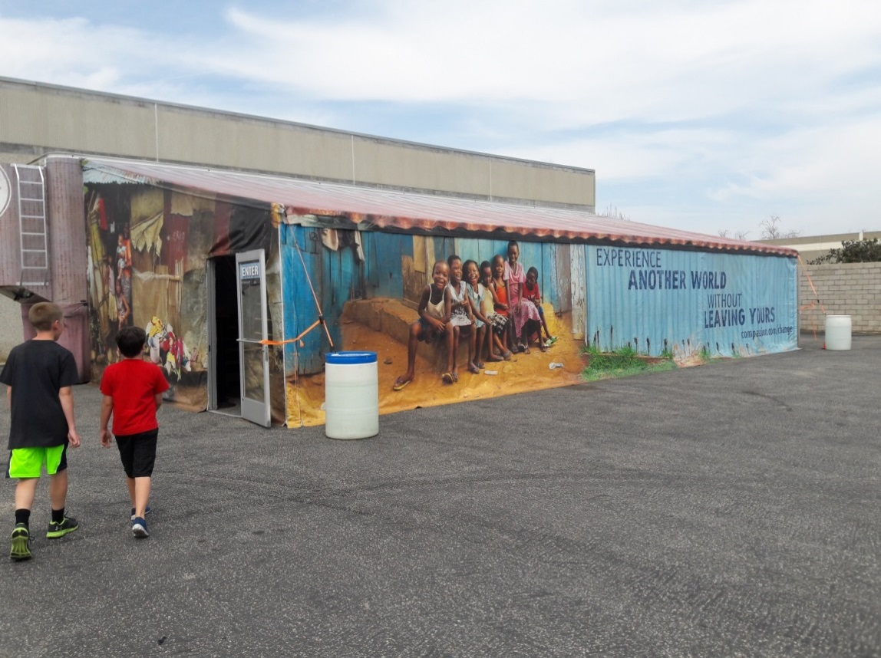

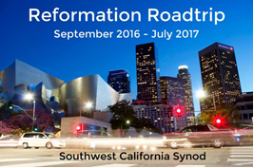

Join us on a Roadtrip celebrating the 500th anniversary of the Reformation and learn about the impact of Martin Luther on the historical and modern church!  
  
Bishop Guy Erwin will carry Luther's message all around the Southwest California Synod with a series of six paired lectures, presented on various Saturdays from September 2016 to July 2017.   
  
For each session, the first lecture will be an introduction to Martin Luther. Lunch will be served, followed by an in-depth lecture about Luther's teachings. Come hear one, or come hear all; the in-depth lecture will be different every time!

Each Reformation Roadtrip event will be held from 10:00 a.m to 2:30 p.m. The cost is $10 per event, or $50 for all six. Please bring payment in cash or check the day of the event. Checks should be made out to the Southwest California Synod.  
  
To make your reservations for one or more Reformation Roadtrip events, please contact Jason Ramirez at [**jramirez@socalsynod.org**](mailto:jramirez@socalsynod.org).

**Reformation Roadtrip Locations**

|  |  |
| --- | --- |
| November 19, 2016  First Lutheran Church  2900 West Carson Street  Torrance, CA 90503 | March 25, 2017  Emmanuel Lutheran Church  6020 Radford Avenue  North Hollywood, CA 91606 |
| January 21, 2017  Hill Avenue Grace Lutheran Church  73 North Hill Avenue  Pasadena, CA 91106 | May 13, 2017  Ascension Lutheran Church  1600 East Hillcrest Drive  Thousand Oaks, CA 91362 |
| http://files.constantcontact.com/1ed75ba9001/dbd452b5-e1ea-4550-9bf5-e78686628b8d.jpg | July 15, 2017  Mt. Carmel Lutheran Church  1701 Fredericks Street  San Luis Obispo, CA 93405 |



LIBRARY NEWS

**Easter is fast approaching. For many children, Easter is mostly candy, chocolate bunnies, baskets, colorful eggs, and new clothes. We adults know that the real meaning of Easter is the foundation of our faith. We know about the: Last Supper, Trial, Crucifixion, Resurrection, and Ascension. But do we really? What was on the menu at the Last Supper? How many times did Jesus speak on the cross? How many times did He appear after the resurrection and to whom?**

**If you would like to find out more about these Easter events, please check the Book Cart. It features lots of interesting reading material to enrich your understanding of Easter and the basis of Christianity. For the children, the Book Cart offers books on Easter and on Spring.**



**Middle School Winter Camp Feb. 24-26, 2017**

**Shepherd of the Valley was able to go to middle school winter camp at El Camino Pines on February 24th-26th. Amanda Burns and Marc Mohr went as the leaders. Bryan Honda attended as a camp volunteer for the weekend. Claire Arnold, Cassidy Yates, and Kylea Goldberg went as the campers. We were very fortunate for snow to fall on Sunday morning. The theme was quantity over quality. We look forward to attending summer camp now from July 23rd-28th, 2017.**

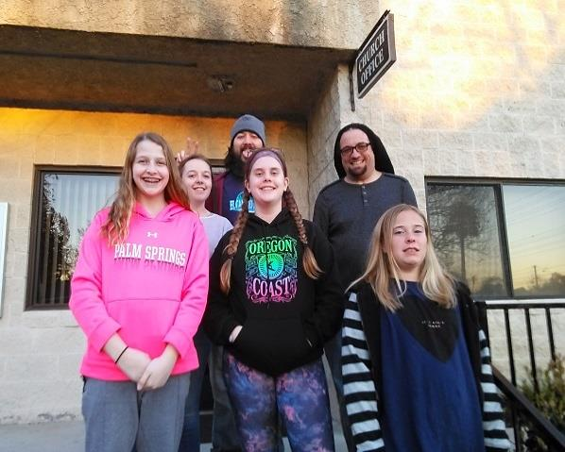



**Belgian Waffle Sunday**



April 30th, 9AM-Noon

Join us on the Patio for Waffles, whipped cream,   
 Strawberries, sausages, Orange Juice & Coffee

$5.00

Proceeds to benefit

AED (Automated external Defibrillator)

Sponsored by the Women of SVLC



[**https://www.facebook.com/events/281113582319823??ti=ia**](https://www.facebook.com/events/281113582319823??ti=ia)

**Join us for an afternoon of light refreshments and gather with women of different faiths from Ventura County for conversation and to begin the work of building local relationships.  
  
Thanks for sharing this with women in your life and faith community.  
  
RSVP not necessary but helpful:** [**Leblanc@CalLutheran.edu**](mailto:Leblanc@CalLutheran.edu) **or**[**(805) 493-3936**](tel:(805)%20493-3936) **Questions: Desta Goehner,** [**Desta@CalLutheran.edu**](mailto:Desta@CalLutheran.edu) **or**[**(805) 493-3152**](tel:(805)%20493-3152)[**#CLUconnect**](https://www.facebook.com/hashtag/cluconnect)



**Movie night**

**On Saturday, March 18th, the Fellowship Committee hosted the thought provoking movie, “God’s Not Dead 2”. Eighteen members of our congregation came out to enjoy the free movie and popcorn in Eichele Hall. The movie starred Melissa Joan Hart, as a high school history teacher who comes under fire for answering a student’s historical question about Jesus. The school board voted to suspend the teacher when she refused to apologize for talking about Jesus in the classroom. Forced to stand trial to save her career, the teacher hired a young lawyer (Jesse Metcalfe), whom used an interesting strategy to defend her classroom history discussion. Pat Boone also had a role in the movie.**

**Look for other fun Fellowship activities coming later this year including: our annual church picnic, theater night, chili cook-off, pie social, and Nativity sharing.**

**FAITH IN ACTION**



***Dear friends and family, if there are friends and loved ones whom you would like to have prayers for, or military persons on active duty, please contact the church office at 526-7577 and we will list them in our bulletin and newsletter.***

REMEMBER IN PRAYER…Good Shepherd Lutheran School youth and church leaders.

***Undergoing cancer therapy***

Mike Denmark (*Cathie Badillo’s brother-in-law*), Wendy Bealliu, Brian Apuzzo, Barbara Corrigan

***Under convalescent or hospice care***

**E-mail svlcpray@svlcsimi.com with any updates you may have on persons listed for prayers. *Thank you***

Rev. James Sherrill & Mae Maddoax

*(Cathie Badillo’s aunt & uncle),* Craig Wells,

Justin Scholberg (*Corrine Stevenson’s father*),

Jean Stevenson (*Pastor Gary’s mother*).

***Undergoing surgery, various tests, treatments, recuperating and continued comfort***

Jeanne Shafer, Kent Keith, Jean Schlosser, Betsy Hospodar, Shirley Ruben, Brett Lea (*Irene Tangren’s grandson*), Angel Rodriquez, Joyce Bruce, Charlotte Weldon, Donna Ritter. Please lift Kelli Stephens’ daughter Taylor up in prayer.

***Military Recognition:***

We would like to honor our military by recognizing family members from our church currently serving. If you have a family member now serving in the military, please call Sally Valderrama @ 805-527-4061 or Email (Sally.Valderrama@gmail.com) for further details.

***The congregation of Shepherd of the Valley Lutheran Church thanks you for your service***

MC900057021[1]MC900351209[1]

**Sport Equip.etc.**  
S

MC900113476[1]MC900383832[1]

**PLEASE…HELP SUPPORT GOOD SHEPHERD LUTHERAN SCHOOL At…**

**Luther’s Attic…**a thrift store which is located in the city of Moorpark

189 E High Street

Monday – Saturday 10AM – 4PM

(805) 523-7188  
  
[**Visit our website here**](http://www.luthersatticmoorpark.com/)

**Give donations, shop and/or volunteer your time!!**

It all helps the Christian school ministry here in Simi Valley.

MC900057304[1]

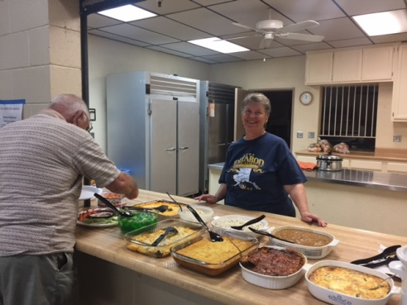Y.I.M.A.H. Potluck Luncheon

(**Y**oung **I**n **M**ind **A**nd **H**eart 50yrs. and over)

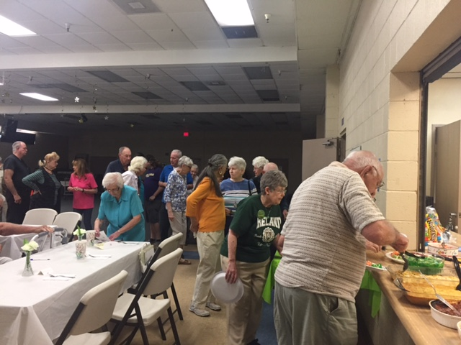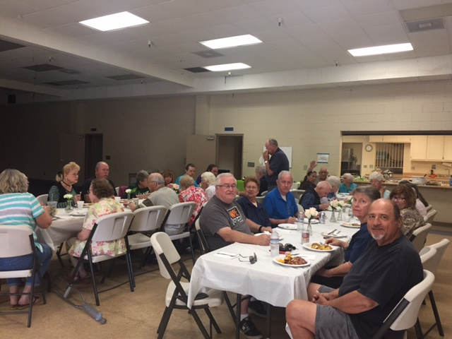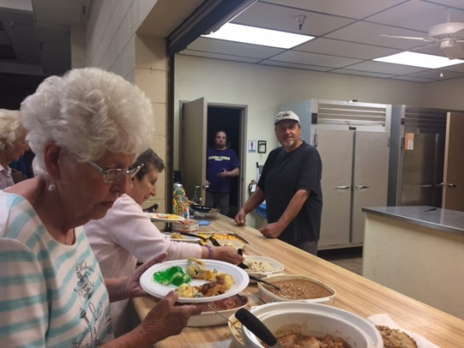This event is typically for seniors 50yrs of age or over but…**Hey** **who’s counting**, come and join in any third Thursday of the month. For further information please call: Edith Engemann 805-526-9020 **or** the church office 526-7577.

MC900047820[1] ***Samaritan Center of Simi Valley***

Shepherd of the Valley Lutheran Church serves a meal to the less fortunate at the ***Samaritan Center*** (located at 280 Royal Ave) on the **1st Wednesday of every month from 4:45 – 6:00.**

**We need volunteers to serve food** at the Samaritan Center,

**AND…buy and deliver food or donate money**

If you would like to help, please contact Yvonne Baird at 584-2521. Thank you for your prayers

**interface 2017**

**The women of Shepherd of the Valley support this organization so it can support women in Ventura County that have suffered from family violence. Interface’s Family Violence Intervention Servicesdepartment provides comprehensive family violence programming that aims to prevent, interrupt and end the cycle of violence within family systems.   
  
I have collected enough of a few items but none of others. Could you look through the list below and see if you can purchase some of the items I am short of to make up care kits. For more information, please Contact Carol Ramsey by email @ carolandken@roadrunner.com  
  
Donations of regular sized items listed below may be placed in the box in the narthex or brought to Circle meetings.  ( ) Number I already have.   
  
Shampoo (4) Conditioner (0) Brush (2) Comb (2) Lotion (0) Toothbrush (5) Toothpaste (1) Soap (16) Tampons (1) Deodorant (0) Disposable razors (4) Pocket size Kleenex (0)**



**Invites *you* to share a *free* community meal every Thursday at 5:00 p.m.**

**The café is located at 4191 Cochran Street.**

**For more information please call 805-526-7577**

**“A dining service to those who are suffering economic hardship,**

**homelessness or who are lonely and wish to have a dining companion”**

**Amenities at the café:**

* **Mealtime is served beginning at 5:00p.m.–6:30 p.m. every Thursday.**
* **Fresh home cooked meal served in a family atmosphere with home style table settings.**
* **To-go snack bags are offered.**
* **Highchairs and booster seats are available for the younger family members.**
* **There are wheelchair accessible entrances and bathrooms available.**
* **Prayer requests can be satisfied.**

**Still Waters exists because of our wonderful volunteers and contributions from the congregation, but we are in desperate need of the following in order to keep this program going:**

**Someone to go to Food Share twice a month on Wednesday morning. Our assigned time to shop is 8 am to 9 am. Time commitment 2 hours per Wednesday.**

**Someone to sub when our regular volunteers go on vacation or are unavailable. Commitment 2 hours.**

**Please consider giving a few hours of your time to help this outreach. It is so important.**





**BINGO FUNDRAISER NIGHT IS COMING**

**CIRCLE YOUR CALENDAR FOR MAY 20th FROM 5 p.m. - 8 p.m.**

**This will be a fundraiser for both Still Waters and Christmas Shoppe. There will be food to buy, prizes for youth and adults, 50-50 ticket drawing and some silent auction items.**

**Cost is $5.00 per card. Come have a fun family night while helping these 2 programs.**

**Hope to see you there.**

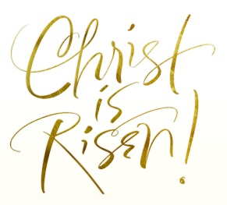

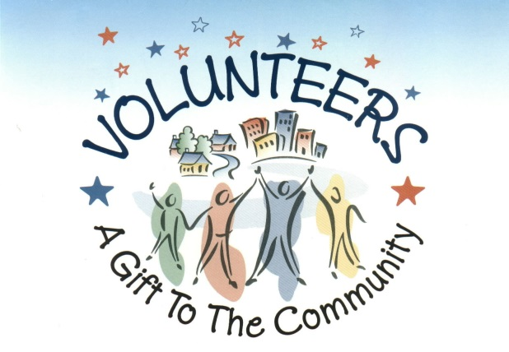

***HOSPICE VOLUNTEERS NEEDED***

**Adventist Health Hospice is looking for volunteers who would like to give back to their community. We are looking for volunteers who are 21 years old or older, who would like to donate their time for being of service to terminally ill patients. Contact Knarik or Sally @(800) 654-4747 for more information.**

**Happy Easter!**

**We hope that everyone is experiencing a very joyous and Happy Easter season as we celebrate the Resurrection of our Lord and Savior Jesus Christ. Christ is Risen! He is Risen Indeed!**

**Here are a few Easter related questions to consider this Easter season. We know about the Last Supper, trial, crucifixion, resurrection and ascension. But do we really? What was on the menu at the Last Supper? How many times did Jesus speak on the cross? Jesus appeared how many times after his resurrection? Where? And to whom? Some interesting questions to think about, are they not? Discuss them during this Easter season with your family and friends and see what answers you arrive at. Some of the answers to these thought provoking questions may not be definitive and are possibly up for debate by theological scholars and historians, but they will definitely get you thinking and talking. It will not only be enlightening, but educational and you may learn more about the true significance of Easter. The answers to these questions can be found in the many books that we have available in our own SVLC library.**

**As you prepare for Easter, will you be hosting a family Easter brunch or dinner? Why not purchase the required groceries and necessary accompaniments with scrip gift cards. We have scrip for Vons, Pavilions, Stater Bros., Sprouts and Albertsons (upon request). Planning to gift the children, grand-children or great grand-children with Easter baskets, bunnies, candy or colored eggs? Or maybe new spring outfits are on your “must buy” list for this year and you shop at Target, Kohl’s, Walmart, TJ Maxx or Ross, you can purchase all of those items with gift cards as well. We also offer a wide variety of specialty shops, including the ever popular See’s Candies. We have a list of all our participating vendors upon request. Whatever it is you need, we have your gift cards and remember that a percentage of each and every card you purchase is returned to our church. What better way to shop for all the things you want or need and at the same time help support Shepherd of the Valley.**

**We want to wish the church staff, especially our new Pastor Jennifer Chrien and our new Parish Administrator, Roxanne and the entire Shepherd of the Valley Lutheran Church congregation, a very joyous and blessed Easter season!**

**In His Service,  
Marvin and Jenny Kidd, SVLC Scrip Committee**

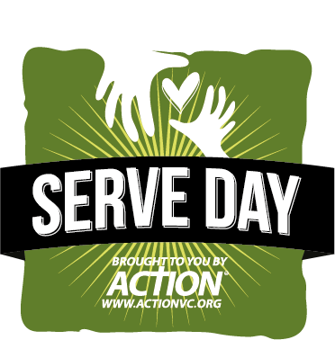**WE’RE BETTER ...**

**Serving Together!**

**May 6th**

**Sponsored by ACTION**

**8-12**

**Meet at Apollo High school at 8:00am**

**SVLC questions contact Julie Honda**

**(805) 341-3866** [**R6Hondas@roadrunner.com**](mailto:R6Hondas@roadrunner.com)

**sign up on the patio or contact Julie**

**Our community will be changed by Christ’s Church  
working together to show God’s love through meeting real needs.**

**We’re better serving together…**

**● Serving alongside other local churches, the Church unites to make  
 Jesus known in a powerful way throughout Ventura County  
 (John 17:20-23)**

**● Serving together with the local community groups (e.g., agencies,  
 schools, residential facilities), we connect with these folks to make  
 Christ known in very tangible ways (I John 3:16)**

**● Inviting our non-believing friends to serve with us, they see our faith in  
 Christ is alive and real (James 2:15-17)**

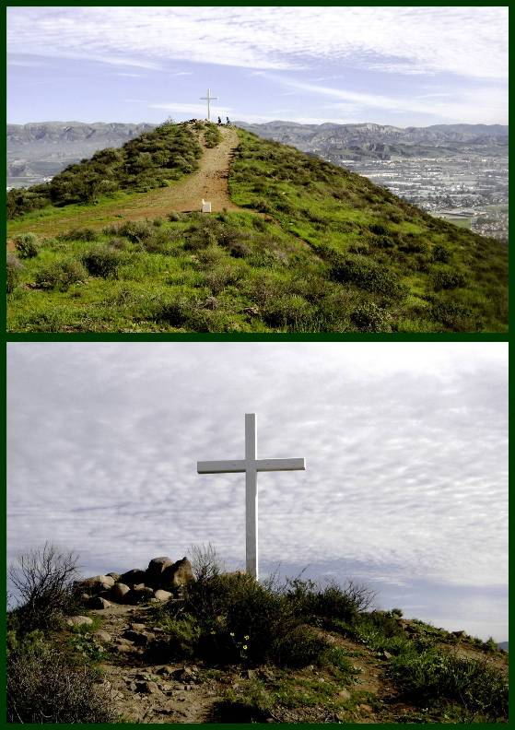

**ANNUAL HIKE TO THE CROSS**

April 9th @ 3:00pm

**Join members from Trinity and Shepherd of the Valley Lutheran Churches for a journey of what Jesus went through during His steps to Mt. Golgatha, “Stations” performed by members of both parishes. Please meet at the field entrance at the corner of Washburn and Los Amigos on West end of Simi.  
  
3 Levels of Hikes! 35 min. – Live “Stations of the Cross” 25 min. – “Meditational” 15 min. - “flat walk”**





**ELEMENTARY K-5th grade:**

**Sunday School –** Meets in the purple room every Sunday @ 9:45am. We will NOT have Sunday School on Sunday, April 16th since its Easter.

**Spark –** Spark will meet from 6:30-7:45pm on Thursdays except on April 13th.

**Easter Egg Hunt** – The Easter egg hunt will be on Sunday, April 9th at 9:30am. Meet at the playground gate no later than 9:30am. Bring a bag or an Easter basket.

**Palm Sunday Breakfast –** The youth will be helping with the Palm Sunday breakfast from 9am-11:30am on Sunday, April 9th. Come on out and support the youth.

**Midnight Mission –** 5th graders on up may come to help with Midnight Mission and serve lunch on Monday, April 17th from 10am-4pm. Please let Marc know by Thursday, April 13th.

**Save The Dates: VBS: July 17th – 21st (Hero Central) & Summer Camp: July 23rd – 28th**

**MIDDLE SCHOOL 6th-8th grade:** 

**Confirmation** – Confirmation will take place every week in April except on April 12th.

**Middle School Chat** – We will have middle school chat on **Sunday, April 23rd 9:45am**. We will walk to McDonald’s on **April 23rd**. Please bring a few dollars for breakfast. NO MS Chat on

**Palm Sunday Breakfast –** The youth will be helping with the Palm Sunday breakfast from 9am-11:30am on **Sunday, April 9th**. I will be having three shifts that you can choose to help with at either 8:15-9:30am, 9:30am-10:45am, and 10:45am-12pm. If you can’t volunteer please consider donating juice. We are need of 3 ½ gallon apple juice and 2 ½ gallon orange juice.

**Holy Week Schedule** – You’re invited and encouraged to come to the Hike to the Cross on **Sunday, April 9th** at 3pm – meet at Washburn and Los Amigos at the west end of Simi, the Reenactment of the Living Last Supper on **Thursday, April 13th** at 5:30pm or 7:30pm, and the Good Friday Service on **Friday, April 14th** at 12pm and 7pm.

**Midnight Mission –** Middle school youth are invited and encouraged to come help with Midnight Mission and serve lunch on **Monday, April 17th** from 10am-4pm. Please let Marc know by Thursday, April 13th.

**Hike N Lunch** – Meet at the church on **Sunday, April 23rd** at 12:15pm and we will return to the church by 4:45pm. Bring around $5 for lunch as we will stop and eat at In N Out. Bring a water bottle and please wear sunscreen. We will be hiking in the Knolls/Rocky Peak area.

**Save The Dates: VBS: July 17th – 21st (Hero Central) & Summer Camp: July 23rd – 28th**

**HIGH SCHOOL 9th-12th grade:** 

**Youth Group –** Youth group will take place in the youth room at church on Thursdays from 8-9:30pm. We will not have youth group on April 13th.

**Palm Sunday Breakfast –** The youth will be helping with the Palm Sunday breakfast from 9am-11:30am on **Sunday, April 9th**. I will be having three shifts that you can choose to help with at either 8:15-9:30am, 9:30am-10:45am, and 10:45am-12pm. If you can’t volunteer please consider donating juice. We are need of 3 ½ gallon apple juice and 2 ½ gallon orange juice.

**Holy Week Schedule** – You’re invited and encouraged to come to the Hike to the Cross on **Sunday, April 9th** at 3pm – meet at Washburn and Los Amigos at the west end of Simi, the Reenactment of the Living Last Supper on **Thursday, April 13th** at 5:30pm or 7:30pm, and the Good Friday Service on **Friday, April 14th** at 12pm and 7pm.

**Midnight Mission –** High school youth are invited and encouraged to come help with Midnight Mission and serve lunch on **Monday, April 17th** from 10am-4pm. Please let Marc know by Thursday, April 13th.

**Hike N Lunch** – Meet at the church on **Sunday, April 23rd** at 12:15pm and we will return to the church by 4:45pm. Bring around $5 for lunch as we will stop and eat at In N Out. Bring a water bottle and please wear sunscreen. We will be hiking in the Knolls/Rocky Peak area.

**Western States Youth Gathering –** This event will be held at California Lutheran University **June 28th – July 2nd**. This event is open to all incoming 9th graders through all outgoing 12th graders. Please let Marc know if your child can attend.

**Save The Dates: VBS: July 17th – 21st (Hero Central) – Help Volunteer**

**College /Young –adult: **

**College/Young Adult Group** – **Sunday, April 9th and April 23rd** at Marc’s house from 8-10pm.

**Holy Week Schedule** – You’re invited and encouraged to come to the Hike to the Cross on **Sunday, April 9th** at 3pm – meet at Washburn and Los Amigos at the west end of Simi, the Reenactment of the Living Last Supper on **Thursday, April 13th** at 5:30pm or 7:30pm, and the Good Friday Service on **Friday, April 14th** at 12pm and 7pm.

**Save The Dates: VBS: July 17th – 21st (Hero Central) – Help Volunteer**



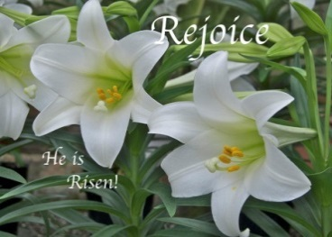 **April 2017 Events**

***Sunday Monday Tuesday Wednesday Thursday Friday Saturday***

|  |  |  |  |  |  |  |
| --- | --- | --- | --- | --- | --- | --- |
|  |  |  |  |  |  | **1**   8:00am-Al-anon  10:00am-AA/Library   8:00am -GSLS  Dinner Auction-  Eichele Hall |
| **2**  8:30am-Traditional  9:45am-Contemporary  9:45am-Sunday School   K-5th grades  11:00am-Traditional  7:00pm-Al-anon | **3**  9:00am Office Open  6:00pm-Stretch /Tone  7:00pm-Al-anon  7:30pm-Al-ateen | **4**  9:00am Office Open 10:00am-SVLC/Attic  5:00pm-American  Heritage Girls 6:00pm-Stretch /Tone  6:00pm -AA | **5**  9:00am Office Open  5:00pm-Lenten Bible Study 5:00pm- Community Dinner-   Samaritan Center  6;00pm-Lenten Soup Supper  6:45pm-Lenten Service  7:00pm-Confirmation  7:00pm- Simi Church | **6**  9:00am Office Open  10:00am-SVLC/Attic  5:00pm-Still Water   Café Open  6:00pm-Stretch /Tone  6:30pm**-** SPARK  8:00pm-Youth Group | **7**  9:00am-Office  Open | **8**  10:00am-AA-Library  8:00am-Al Anon |
| **9**  8:30am-Traditional   9:00am Palm Sunday   Breakfast-Courtyard  9:30am Easter Egg   Hunt  9:45am-Sunday School  K-5th grades  9:45am-Contemporary  11:00am-Traditional  3:00pm-Cross Hike  7:00pm-Al-anon | **10**  9:00am-Office Open  6:00-Stretch /Tone  7:00-Al-anon  7:30-Al-ateen | **11**  9:00am-Office Open  10:00 SVLC/Attic  6:00-Stretch / Tone  6:00-AA  7:00-Hannah Circle  Women’s Study | **12**  9:00am-Office Open  5:00pm-Lenten Bible Study 6:00pm –Lenten Soup Supper  6:45pm-Lenten Service | **13**  9:00am-Office Open 10:00am-**NAOMI Circle** 10:00am-SVLC/Attic  5:00pm-Café Open 5:30pm-**Living Last   Supper**  6:00pm-Stretch /Tone 7:00pm-**Living Last   Supper** | **14**  9:00am-Office Open  12:00pm-**Good Friday Service**  7:00pm **Good Friday Service** | **15**  8:00am-Al-anon  10:00am-AA Library  10:00am-SVLC/   Attic |
| **16  EASTER**  6:00am-Sunrise Service  8:30am-Traditional  9:45am-Contemporary  11:00am-Traditional  7:00pm-Al-anon | **17**  9:00am-Office Open  6:00pm-Stretch/   Tone  7:00pm-Al-anon  7:30pm-Al-ateen | **18**  9:00am-Office Open  5:00pm-American  Heritage Girls  6:00pm-Stretch/ Tone  6:00pm-AA 7:00pm-Happy   Squares  7:00pm-SVLC   Council | **19**  9:00am-Office Open  7:00pm-Confirmation | **20**  9:00am Office Open  10:00am-SVLC/Attic 11:30-**Y.I.M.A.H**. –  Potluck Seniors 50+  5:00pm-Café Open  6:00pm-Stretch /Tone  6:30pm**-** SPARK  7:00pm-Al-anon  8:00pm-Youth Group | **21**  9:00am-Office Open | **22**  8:00am-Al-anon 10:00am-AA-Library |
| **23**  8:30am-Traditional  9:45am-Contemporary  9:45am- Middle School   Chat  11:00am-Traditional  7:00pm-Al-anon  8:00pm-College Grp. | **24**  9:00am-Office Open  6:00-Stretch /Tone  7:00-Al-anon  7:30-Al-ateen | **25**  9:00am-Office Open  10:00am- SVLC/ Attic  6:00-Stretch/ Tone  6:00-AA  7:00-Youth Board | **26**  9:00am Office Open  7:00 pm-Confirmation | **27**  9:00am-Office Open 10:00am-SVLC/Attic  5:00pm-Café Open  6:00pm-Stretch /Tone  6:30pm**-** SPARK  8:00pm-Youth Group | **28**  9:00am Office Open | **29**  8:00am-Al-anon 10:00am-AA-Library |
| **30**  8:30am-Traditional 9:00am-Waffle Sunday 9:45am-Contemporaty 9:45am-Sunday School   K-5th grades 11:00am-Traditional  2:00pm-Women   Building Bridges 7:00pm-Al Anon |  |  |  |  |  |  |



**For prayer Requests:  
Marilyn Shapiro**[**m1shapiro@aol.com**](m1shapiro@aol.com)

**Youth Director  
Marc Mohr**[**Marc.Mohr@dslextreme.com**](mailto:Marc.Mohr@dslextreme.com)

**Pastor  
Jennifer Chrien**  
[**Jenniferchrien@gmail.com**](mailto:Jenniferchrien@gmail.com)

**Rejoice Band Leader  
Steve Venz**

**Organist  
Saundra Carganilla**

**Parish Administrator  
Roxanne Yatman**[**svlc@dslextreme.com**](mailto:svlc@dslextreme.com)

STAFF

**The Hannah Circle   
Tuesday, April 11th at 7:00pm, at the home of Darlene Bond (2849 Topaz Ave.). We will continue our study on the Women of Faith series “Living Above Worry and Stress”. All are welcome. Bring your bible and an open heart. If you need a ride, contact Carol Ramsey. (see above)**

**The Naomi Circle   
Thursday, April 13th at 10:00am, at the home of Leona   
Stewart (2158 Ardenwood). For more info call Leona @ 805-583-1063.**

**For information on the Women’s groups, please contact Carol Ramsey @ 805-583-5532 or carolandken@roadrunner.com**

**Women’s Bible Study**

**College:**  
**College Hangout: 2nd and 4th Sunday of each month 8-10pm**

**Middle School:**  
**Wednesday – Confirmation 7:00-8:15pm (Sept.-May)  
Middle School Chat – 2nd & 4th Sunday @9:45am (Aug-May)**

**High School:**  
**Thursday – Youth Group 8:00-9:30pm**

**Elementary:**  
**Sunday – Sunday School @ 9:45  
Thursday – Spark )K-5th grade) 6:30-7:45 (Aug. – May)**

**Youth Board Members:**  
**Pastor Jennifer  
Marc Mohr – Youth Director  
Susan Caranchini  
Tom & Shelley McLain  
Jennifer Sterling  
Amanda Burns**

**Church Council Members:**  
**Barry Watters – President  
Julie Honda – Vice President  
Pastor Jennifer  
Lynn Squire – Secretary  
Shelley McLain – Treasurer  
Barbara Bruner  
Lori Lioy  
Tom McLain  
Nancy Mason  
Sue Holloway  
Pat Plyler**

**Women’s Board:**  
**Sue Holloway - President  
Barbara Swanson - Treasurer  
Linda Watters  
Jennifer Sterling  
Carol Ramsey  
Dianne Marshall  
Lisa Gearhart  
Melanie Addy  
Lynn Bonelli  
Kelli Stevens**