

**August**

[**Like us on Facebook**](https://www.facebook.com/SVLCSimi/)

f

**2017**

“Faith in the Public Sphere”   
  
 For the past six months or so, I have been a participant in a program through Pepperdine University called COMMUNITAS. It brings together a cohort of Christian clergy and faith leaders from the greater LA area to create communities and provide resources on a variety of issues that affect our communities. Our first session was in January and focused on building communities within our congregations. The second session, in March, was on education issues.  
  
 For most of our sessions, we come together on the Pepperdine campus in Malibu. This past week, the 15 members of the cohort, plus our two Pepperdine guides (and plus one 10-week-old baby), traveled to Washington, D.C. Our time and focus were on the subject of faith in the public sphere.  
  
 It was certainly an apt time to be in the nation’s capital thinking about this issue. We toured the Capitol on the day Senator John McCain returned to DC. That same day, we walked past activists demonstrating against the repeal; they were gathered on the steps of Lutheran Church of the Reformation, the ELCA congregation just a block from the Supreme Court. In the few days we were in DC, the Senate passed a procedural vote on their plan to repeal the ACA—and then failed to pass the bill itself.  
  
 In our program, we had a very busy four days in the capital. After the tour of the Capitol Building, we went to Arlington National Cemetery. We went to the offices of Sojourners Magazine. We met with representatives of World Vision, the Arab Center DC, and the Institutional Religious Freedom Alliance. We had a little bit of free time to explore the National Mall—I visited the Hirshhorn Museum and the National Gallery of Art.  
  
 One of our conveners from Pepperdine, John Barton, said something our first morning in DC that has stuck with me. He said, “The world does not need more political religion. We have more than enough of that. What the world does need is more religious people who are politically engaged.”  
  
 As Christians, our faith is our primary identity, Christ our primary allegiance. But we are also citizens, members of political communities—local, national, and global. Unless we choose to live a monastic lifestyle, removed from the world, then our lives will necessarily intersect with political matters. Whether it is healthcare for the most vulnerable, or economic opportunity, or stewardship of the environment, our faith engages with political matters.  
  
 In Matthew 25, Jesus tells a parable of the final judgment. “The king will say to those at his right hand, ‘Come, you that are blessed by my Father, inherit the kingdom prepared for you from the foundation of the world; for I was hungry and you gave me food, I was thirsty and you gave me something to drink, I was a stranger and you welcomed me, I was naked and you gave me clothing, I was sick and you took care of me, I was in prison and you visited me.’ Then the righteous will answer him, ‘Lord, when was it that we saw you hungry and gave you food, or thirsty and gave you something to drink? And when was it that we saw you a stranger and welcomed you, or naked and gave you clothing? And when was it that we saw you sick or in prison and visited you?’ And the king will answer them, ‘Truly I tell you, just as you did it to one of the least of these who are members of my family, you did it to me.’”  
  
 Our faith tells us that our actions towards the “least of these” is what we do to our Lord. So as we look at the hungry, the thirsty, the stranger, the naked, the sick, the imprisoned—as we consider the political decisions that affect the least of these is our own community and our own country—our faith calls us to respond. We are people of faith, and the world needs people of faith like us who are willing to be engaged in the public sphere.

Yours in Christ,  
Pastor Jennie

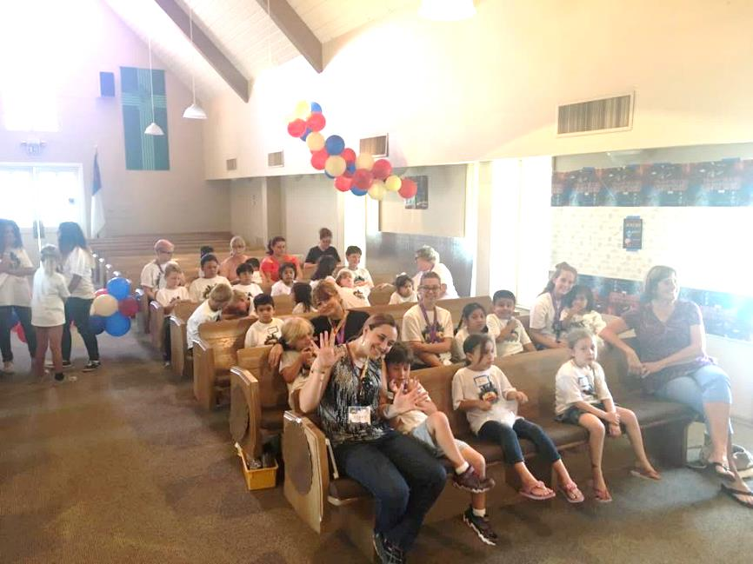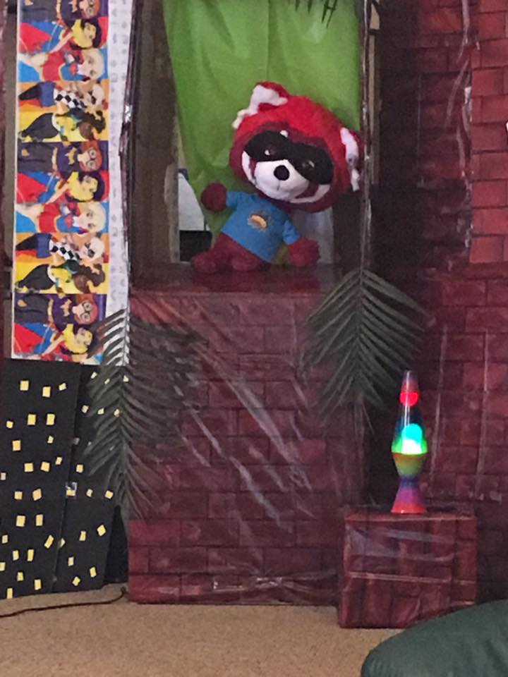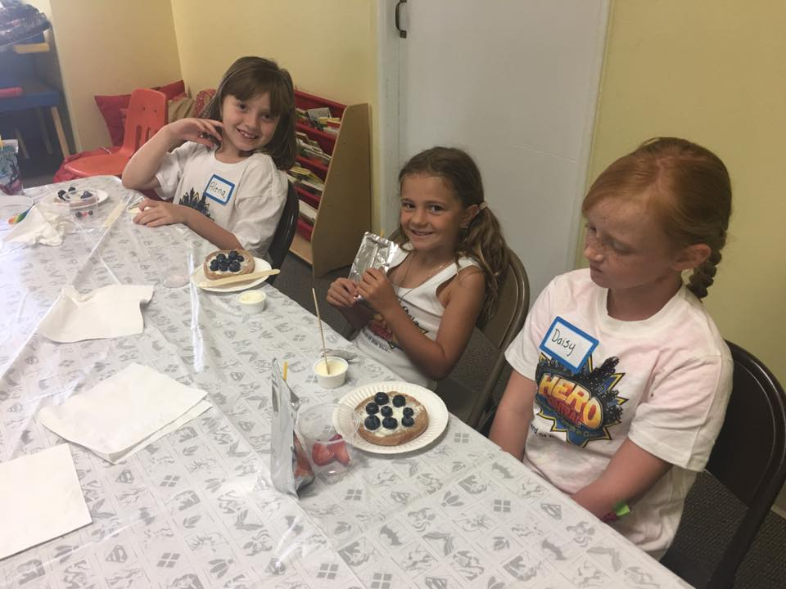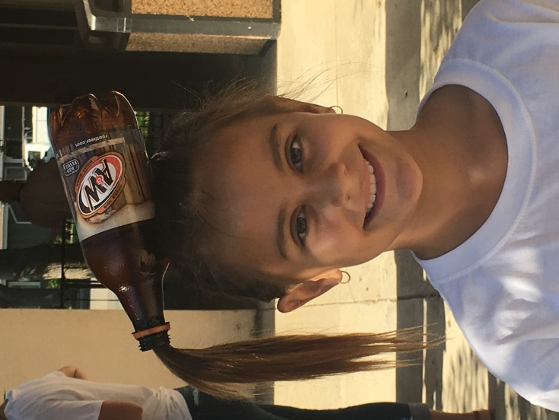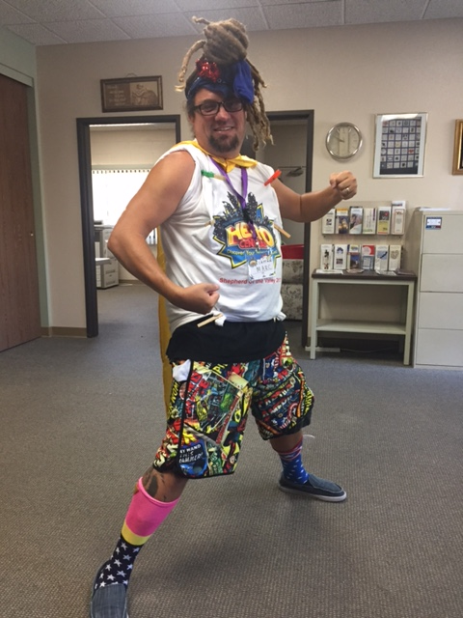

**VBS**

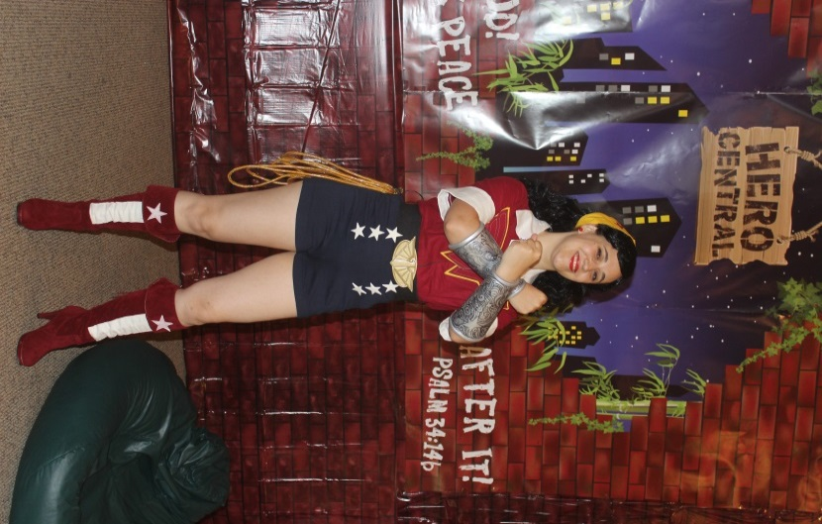

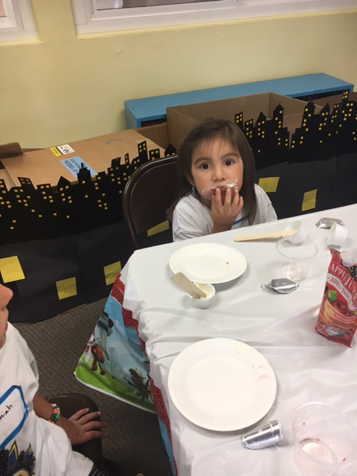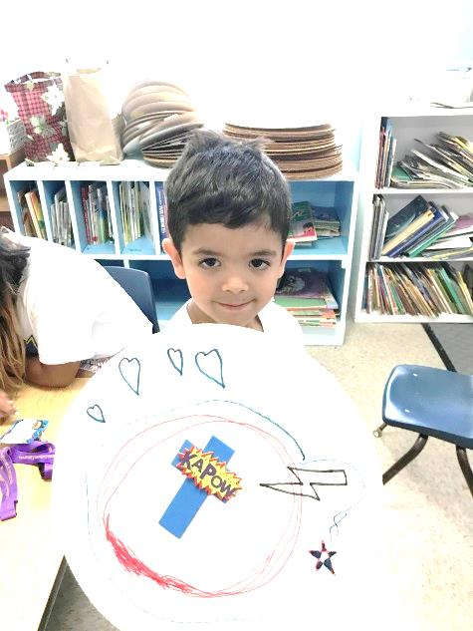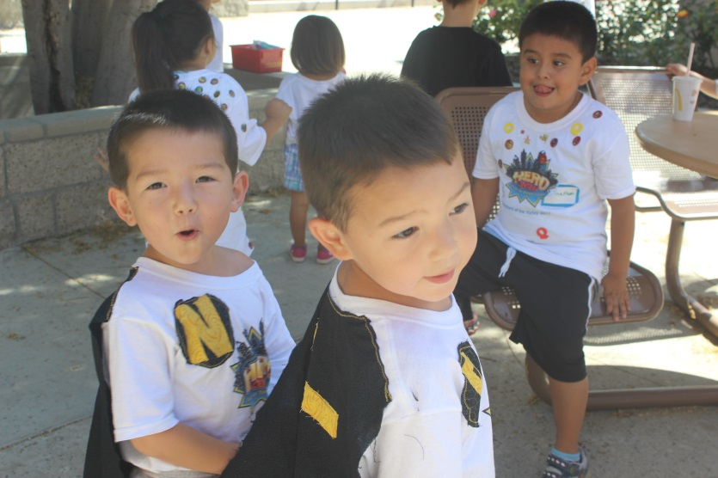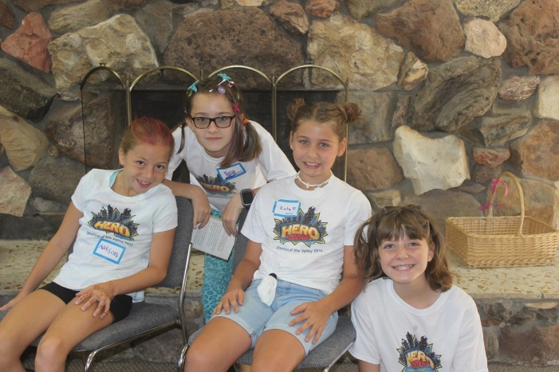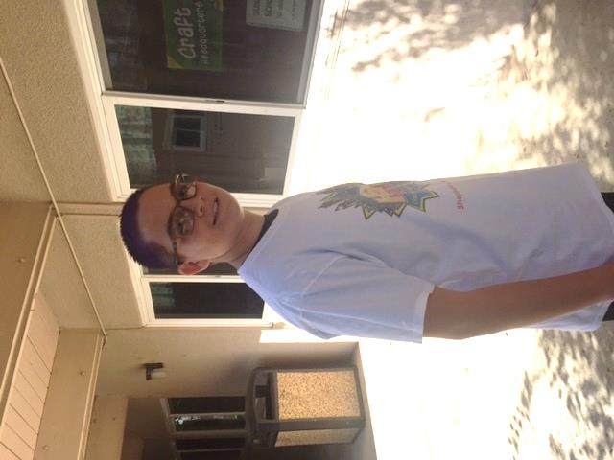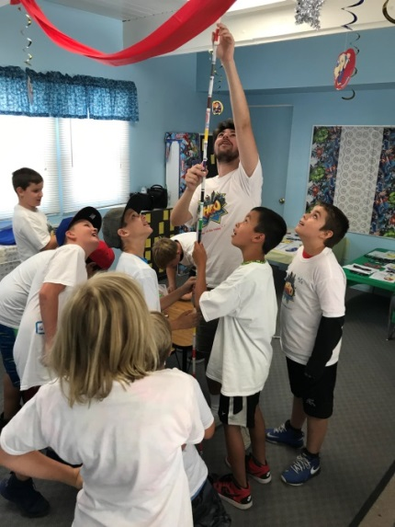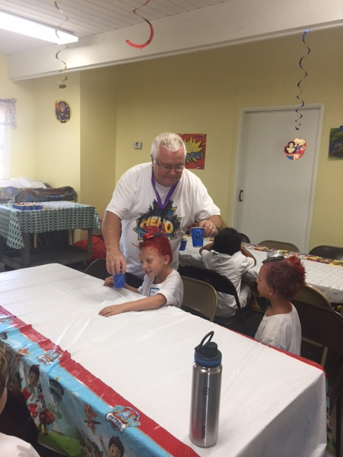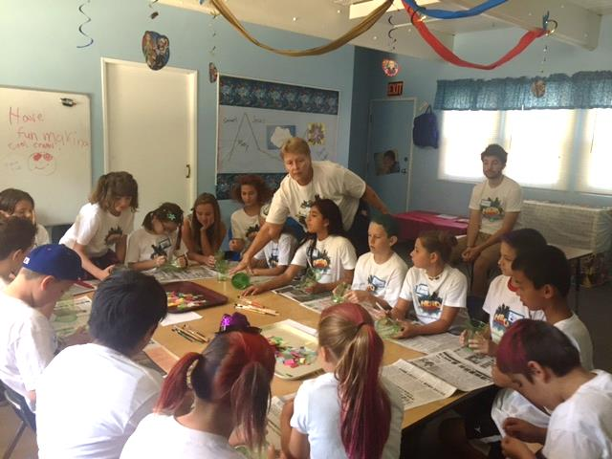

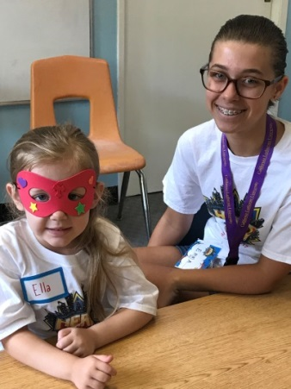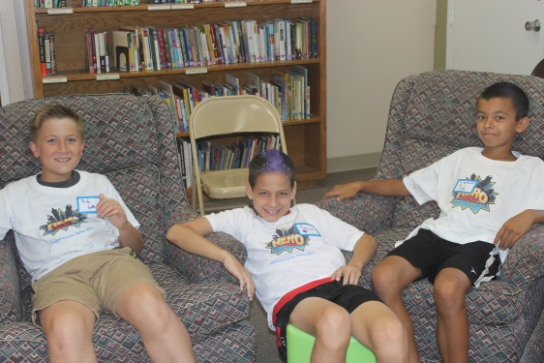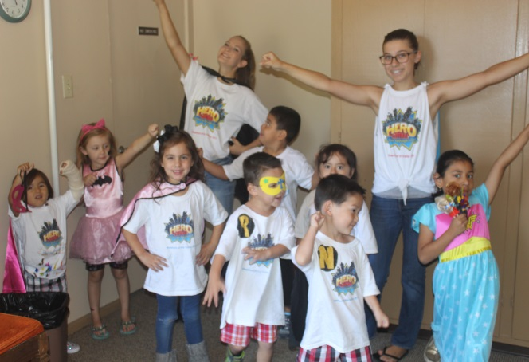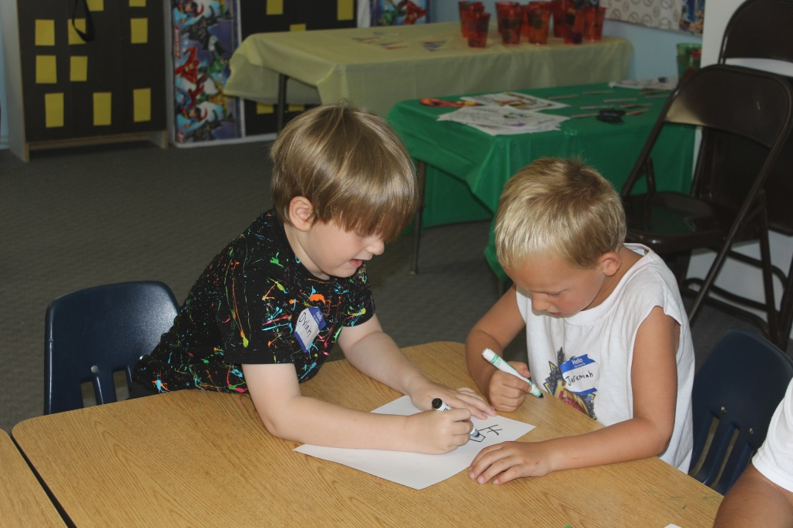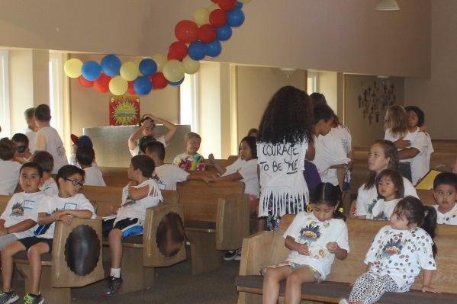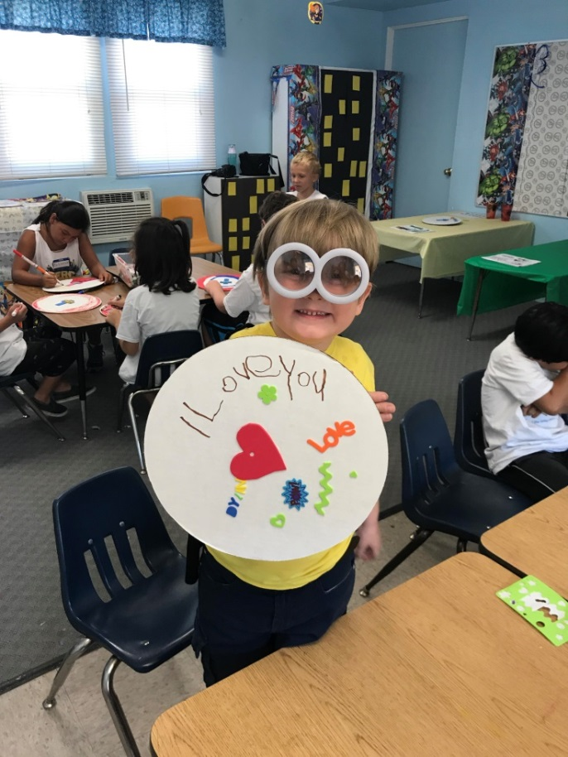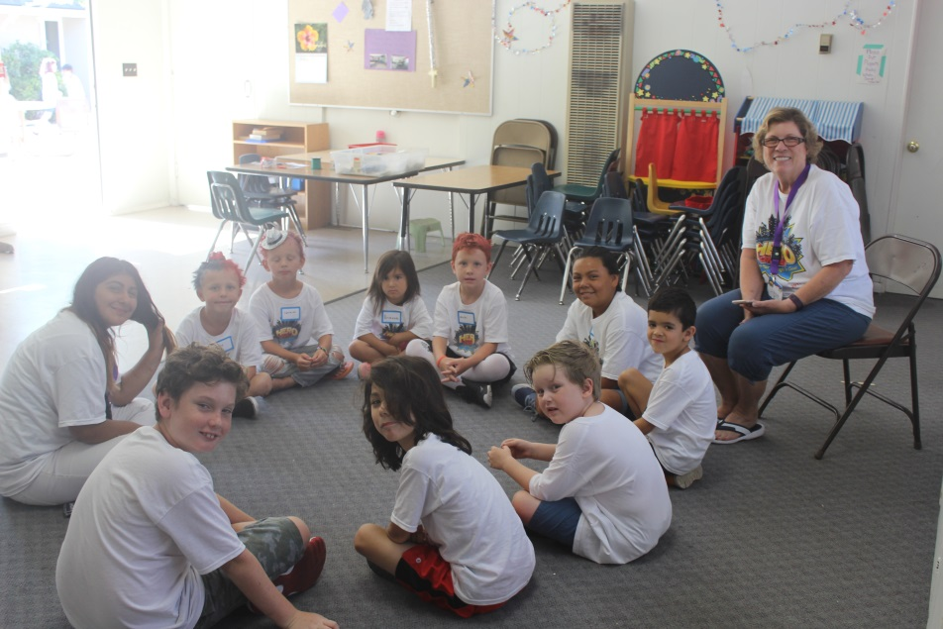

**Jesus said, "Let the  
children alone, and do not hinder them from coming to Me; for the kingdom of heaven belongs to such as these."**



……dine-in……..take-out……or have your food delivered

Phone (805) 581-0976 FAX (805) 581-6387

**Join us to help raise funds for our youth at:  
RED’S BBQ & Grillery Night**

C

L

A

S

S

Wednesday, August 16th  
11:00 am – 9:00 pm  
  
20% of your food bill will go to:

Shepherd of the Valley  
Youth Group

Not valid with any specials, coupons, or discounts. Flier must be present when ordering.  
Flier may not be passed out in the restaurant or the restaurant parking lot.

**First Communion Classes**



If you have a child who is ready for first communion, Pastor Jennie will be having first communion instruction in August. Children (or adults!) who already receive communion but would like a refresher are also welcome to participate.  
  
The age for first communion is at the parents' discretion, but you can contact Pastor Jennie @ [Jenniferchrien@gmail.com](mailto:Jenniferchrien@gmail.com) if you have any questions or concerns about your child's readiness to receive first communion.

The first communion classes will be as follows:  
Session 1 - Wednesday, August 2nd at 2:00pm  
Session 2 - Wednesday, August 9th at 2:00pm  
Session 3 - Sunday, August 13th at 11:30am

**Western States Youth Gathering**

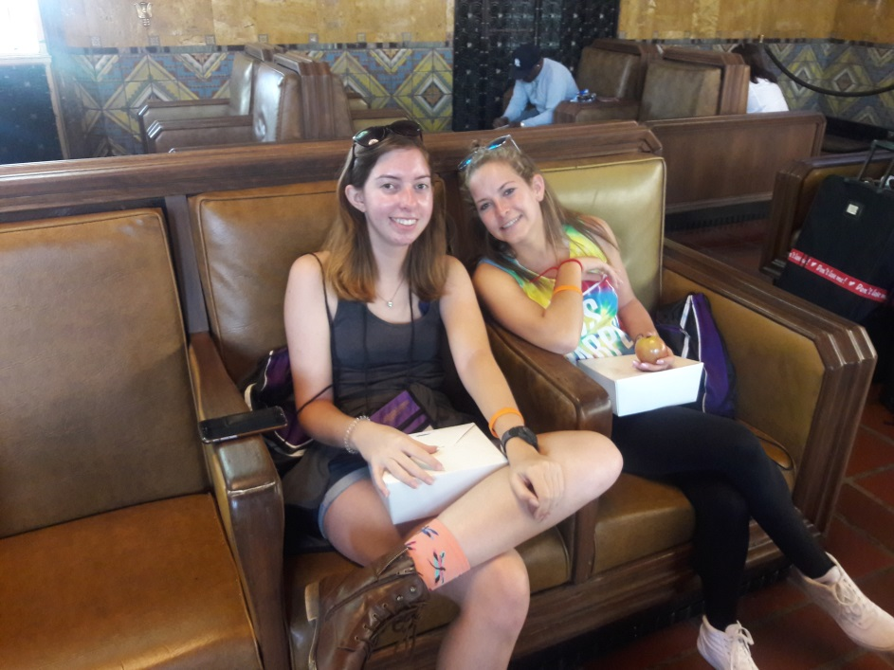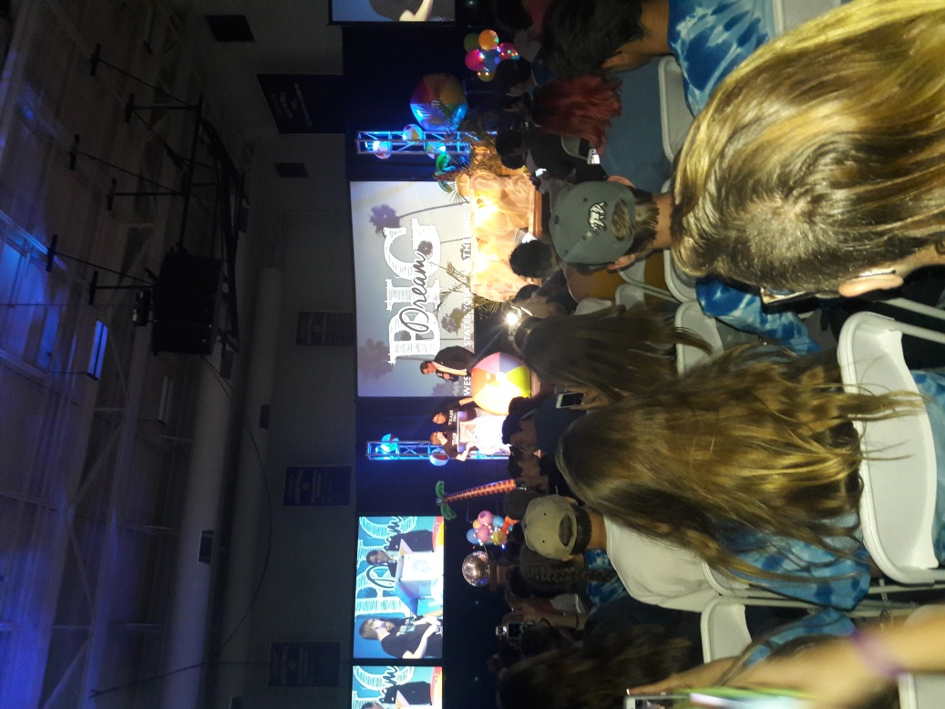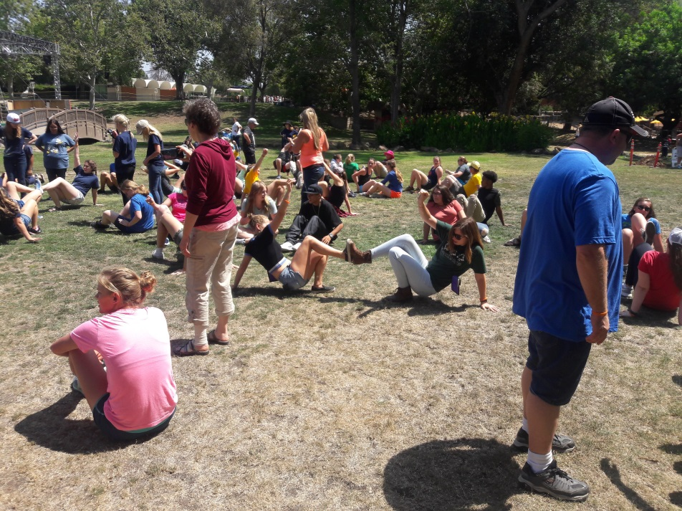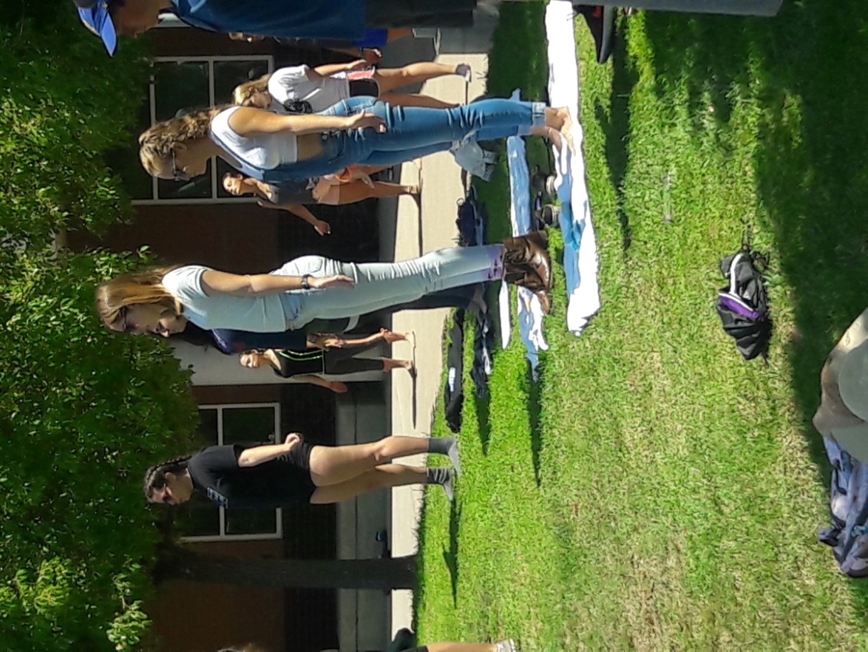

**Western States Youth Gathering happens every three years. This year 550 high school kids and youth leaders met at California Lutheran University from June 28th - July 2nd. The theme was Dream Big. The youth who went from Shepherd of the Valley were Hannah Buch and Amber Caranchini. The leaders who went were Marc Mohr, Pastor Jennifer Chrien, and Amanda Burns.  We all had a great time connecting with God and with others. Thanks for the congregations support.**



LIBRARY NEWS

It is summer and time for backyard BBQs, picnicking, and going to the beach. It is time for vacations, relaxation, and losing yourself in a great book. What, you can’t find a book a home to read? Try our book cart. We have mysteries, romance, science fiction, adventure books and more. There is plenty of great fiction to enjoy on vacation.

This summer for July and August, the book cart will feature only free book exchange books. Take them home or where ever you travel, and enjoy. When done reading, return that book to the book cart, or place another fiction book on the cart. All book donations are gladly accepted. The book cart will also have fun activity books for young children. These books can also be taken home and don’t have to be returned. Good news for the summer… nothing has to be checked out. No cards to sign. Just find a book, read and enjoy.

Happy Reading and Happy Summer!



**STAMPS**

**On behalf of the Shepherd of the Valley Women’s Group, I help collect and re-donate stamps to other charities. This is a very simple, cost-free program where you, as members of the congregation can help charities such as “Boys’ and Girls’ Town,” a Nebraska not-for-profit begun years ago by Father Flannigan, or other worthy charity to earn money by sorting, cleaning and providing those stamps to stamp dealers. All you have to do is collect used stamps. You can clip them with approximately ¼ inch extra from envelopes, or save the whole envelope and let me trim them. Please just leave these cancelled stamps in the Narthex or Office for me (top right hand cubby in printer room). Please contact Bill Wacenske at** [billnjen@sbcglobal.net](mailto:billnjen@sbcglobal.net) **if you have any questions.**



**Q – What is the difference between a guitar and a fish?**

**A – You can’t Tuna Fish**



Please help!!  
   
Marc Mohr is hosting a blood drive

**Wednesday, August 9th from 2:00-8:00pm**

**Shepherd of the Valley Lutheran Church in Simi Valley**

**Marc has a chance to win a scholarship for Seminary** if he has enough people to donate blood. Not only will you be helping those in need of blood and possibly saving a life, you will also be helping a Seminary student further his passion to serve God. Please let Marc know what time works for you and he will sign you up. Each appointment time is 15 minutes (on the hour, half, and every quarter) You can contact Marc via email at: **marc.mohr@dslextreme.com** or text or call him at (805) 304-1367.

BLOOD DRIVE

**FAITH IN ACTION**



***Dear friends and family, if there are friends and loved ones whom you would like to have prayers for, or military persons on active duty, please contact the church office at 526-7577 and we will list them in our bulletin and newsletter.***

**E-mail svlcpray@svlcsimi.com with any updates you may have on persons listed for prayers. *Thank you***

***Undergoing cancer therapy***

Gary Savas, Mike Denmark (*Cathie Badillo’s brother-in-law*), Brian Apuzzo, Barbara Corrigan

***Please keep in your prayers***

Family and friends of Carol Howard and Pauline Nervig and Donna Ritter. Nancy Mason’s mother Ardith Wallen and Kelli Stephens’ daughter Taylor.

***Undergoing surgery, various tests, treatments, recuperating and continued comfort***

Jeanne Shafer, Kent Keith, Betsy Hospodar, Shirley Ruben, Brett Lea (*Irene Tangren’s grandson*), Angel   
 Rodriquez, Joyce Bruce, Charlotte Weldon.

***Military Recognition and Prayers:***

We would like to honor our military by recognizing family members from our church currently serving. Please keep Andrew Thompson in your prayers he is serving in the military. If you have a family member now serving in the military, please call Sally Valderrama @ 805-527-4061 or Email [Sally.Valderrama@gmail.com](mailto:Sally.Valderrama@gmail.com) for furtherdetails.

***The congregation of Shepherd of the Valley Lutheran Church thanks you for your service***



**Sport Equip.etc.**  
S

MC900057304[1]  
MC900383832[1]

**PLEASE…HELP SUPPORT GOOD SHEPHERD LUTHERAN SCHOOL At…**

**Luther’s Attic…**a thrift store which is located in the city of Moorpark

189 E High Street

Monday – Saturday 10AM – 4PM

(805) 523-7188

[**Visit our website here**](http://www.luthersatticmoorpark.com/)

**Give donations, shop and/or volunteer your time!!**

It all helps the Christian school ministry here in Simi Valley.

MC900047820[1] ***Samaritan Center of Simi Valley***

Shepherd of the Valley Lutheran Church serves a meal to the less fortunate at the ***Samaritan Center*** (located at 280 Royal Ave) on the **1st Wednesday of every month from 4:45 – 6:00.**

**We need volunteers to serve food** at the Samaritan Center,

**AND…buy and deliver food or donate money**

If you would like to help, please contact Yvonne Baird at 584-2521. Thank you for your prayers



**Interface**

**The women of Shepherd of the Valley support this organization so it can support women in Ventura County that have suffered from family violence. Interface’s Family Violence Intervention Servicesdepartment provides comprehensive family violence programming that aims to prevent, interrupt and end the cycle of violence within family systems.**

**Donations of regular sized items listed below may be placed in the box in the narthex or brought to Circle meetings. # after each item is the amount needed to complete bags at this time. A good place to purchase these items is the 99 cent store or the Dollar tree. When I have enough to complete the bags containing  these item I will take them to Interface.**

**A big thank you for your kindness and generosity. I have enough to make up 8 gift bags.**

**Things I am collecting to make more bags:  
  
Hair Brush , Comb, Toothbrush, Toothpaste, Disposable razors, Pocket size Kleenex .**

**Thank God for our many Blessings,    
Carol Ramsey**



**Invites *you* to share a *free* community meal every Thursday at 5:00 p.m.  
The café is located at 4191 Cochran Street.**

**For more information please call 805-526-7577**

**“A dining service to those who are suffering economic hardship,**

**homelessness or who are lonely and wish to have a dining companion”**

**Amenities at the café:**

* **Mealtime is served beginning at 5:00p.m.–6:30 p.m. every Thursday.**
* **Fresh home cooked meal served in a family atmosphere with home style table settings.**
* **To-go snack bags are offered.**
* **Highchairs and booster seats are available for the younger family members.**
* **There are wheelchair accessible entrances and bathrooms available.**
* **Prayer requests can be satisfied.**

**Still Waters exists because of our wonderful volunteers and contributions from the congregation, but we are in desperate need of the following in order to keep this program going:**

**Someone to go to Food Share twice a month on Wednesday morning. Our assigned time to shop is 8 am to 9 am. Time commitment 2 hours per Wednesday.**

**Someone to sub when our regular volunteers go on vacation or are unavailable. Commitment 2 hours.**

**Please consider giving a few hours of your time to help this outreach. It is so important.**

**The pantry is used each week for those who need groceries to get them through the week.  Please consider picking up one or more of the items next time you go shopping and place it in the box in the narthex.**

**Canned Spaghettio’s  
Tuna fish  
Canned chili  
Crackers in individual packages  
Pop tarts  
Fiber bars**

**Canned meats  
Cereal  
Granola bars  
Canned fruit   
Juice boxes  
Canned Ravioli**

**THANK YOU, THANK YOU, THANK YOU!!** Still Waters would like to thank those who have already contributed food for our pantry. We are so appreciative. It helps us get through the summer months. We are always in need to replenish the shelves for those in need.

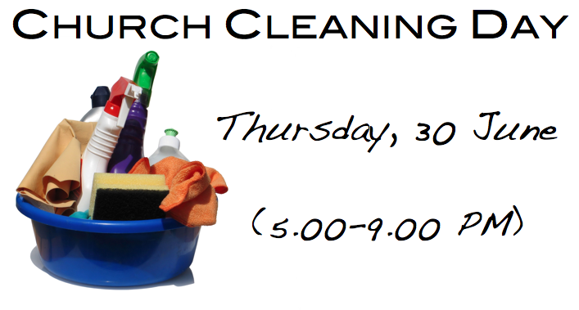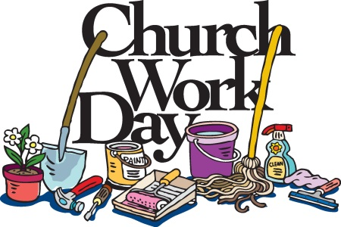

**2nd Annual Youth Room Maintenance Morning**

Saturday, Aug 26, 9am-Noon

**What’s it For?**

* The Nursery
* The blue and purple SS Rooms and supply closet (between the Nursery and Library)
* The Youth Room (above the Office)

**Who’s Invited?**

Anyone willing to help clean, organize, de-clutter, and/or fix things (or is just curious about what we want to get rid of!)

Come for just an hour or all three – **Any help appreciated!**  
Feel free to bring your kids to play in the playground   
(or we can put them to work? ;-)

**Examples of projects we envision:**

Washing walls and windows; Cleaning/sorting the Nursery toys; Organizing the SS supply closet; Fixing/Moving a ping-pong table; Moving stuff to the dumpster; Cleaning windows and/or blinds; Bring your favorite vacuum to help in general cleaning…

**Have questions or suggestions?**

**Feel free to contact Julie,** [**Julie.ostberg@yahoo.com**](mailto:Julie.ostberg@yahoo.com)

**cell: 716-308-5473**

**Women’s Summer Bible Study and Salad Luncheon**



Please join your Sisters in Christ for fellowship, a potluck Salad lunch and a bible study   
“Taking it Slow”

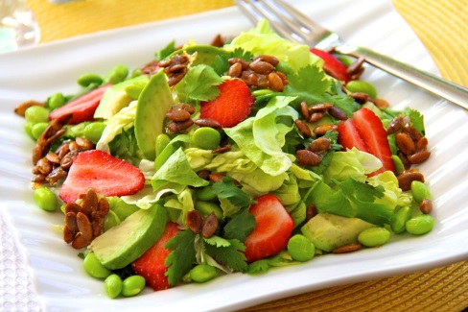

Date: August 26th

Time: 11:30am

Place: Home of Lisa Darin  
 907 Oakmont Ct.  
 Simi Valley, CA 93065

If you need a ride, email or call Carol Ramsey (805) 583-5532

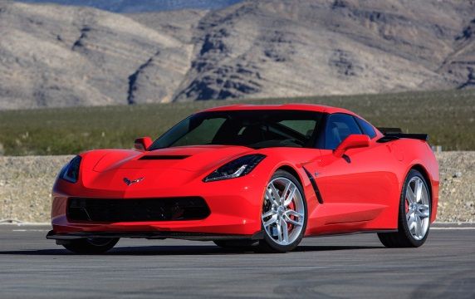



SCRIP



**Summer is in full swing and boy has it been HOT and HUMID!  Now that the summer vacations, trips to the beach and camping excursions will soon be drawing to an end, it won’t be long before the kids (and their parents) will be preparing for the return to school.  That’s right; it’s time for those back-to-school sales.  Simi schools resume Wednesday, August 16th.  Will you and your kids be ready?  It’s time to prioritize, organize and accessorize!  Perhaps the kids need new notebooks, pens, pencils, paper or other school essentials?  Wait a minute……I’m lost back in the days when you used to use those materials for school work, now it’s computers and iPads.  But I guess some kids still use those simple, primitive school implements I mentioned above.  If so, before you shop, don’t forget to stop by the scrip table and get your gift cards.  We have cards for Staples, Office Depot, Target, Best Buy and Walmart.  Maybe it’s new clothing or shoes the kids need before going back to school.  We have cards for Kohl’s, Target, Sears, JC Penney, Ross, TJ Maxx, The Gap, Macy’s, Nordstrom and many others, including a large variety of specialty shops.  Stop by the scrip table and we will be happy to furnish you with a list of all our participating vendors.  So if you patronize any of these fine stores, or any of the other stores that participate in our scrip program, why not buy scrip gift cards and use them to make your purchases.  Some of the stores mentioned above are special order only, we don’t have frequent requests for them or sell them on a regular basis, so order early and we can have your card(s) within one to two weeks.  Remember that scrip is not just for gifting, but for most of your everyday purchases as well and that a percentage of every gift card you purchase is returned to our church.  So what better way to get the things that you want or need and at the same time help support our church.  It’s a win/win situation for you and SVLC.  Come visit us on the patio each and every Sunday between the 8:30 and 9:45 services and the 9:45 and 11:00 services and see what we have to offer.**

**In His Service,                                                                                                                                                                   
 Marvin & Jenny Kidd, SVLC Scrip Committee**

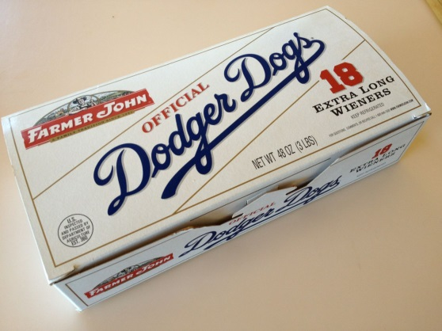In His Service,                                                                                                                                                                                                                                                                              Marvin and Jenny Kidd, SVLC Scrip Committee

**Lutheran Dodger Night  
August 12th 2017**

VBS 2017

SAVE THE DATE

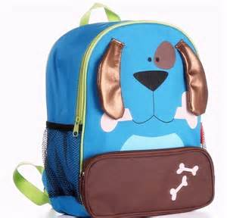

BACKPACK BLESSING

August is coming! For many families that means school is just around the corner! Shopping for school supplies, books, and fall clothes becomes a part of everyone's schedule. Here at Shepherd of the Valley, on Sunday, **August 13**, we want to celebrate and bless the beginning of another school year.

Students of all ages and adults, bring your backpacks or lunch boxes to worship services at 9:00 or 10:30. The services will lift up children and students of all ages, dedicating them to God's glory as we begin a new school year

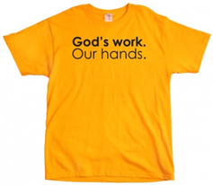

**God’s work Our hands Sunday -** is an opportunity to celebrate who we are as the Evangelical Lutheran Church in America – one church, freed in Christ to serve and love our neighbor. Day of service is **Sunday Sept. 10**. Mark your calendars today!

**September 10, 2017**

**T-shirts** for God's Work, Our Hands Sunday with our church name on it. **$10**. **Must order by August 13th.** See Julie on the patio or contact her at [juliamhonda@gmail.com](mailto:juliamhonda@gmail.com)



**October 21 & 22 2017**

[Click here   
Register to join our team or donate](http://main.acsevents.org/goto/SVLC2017)



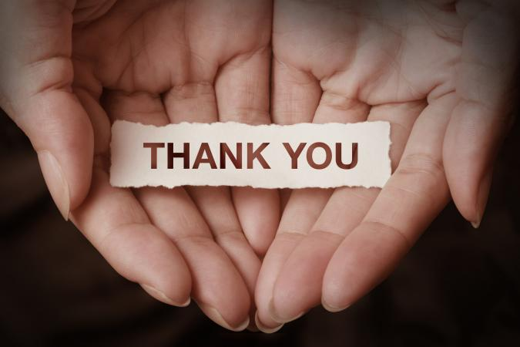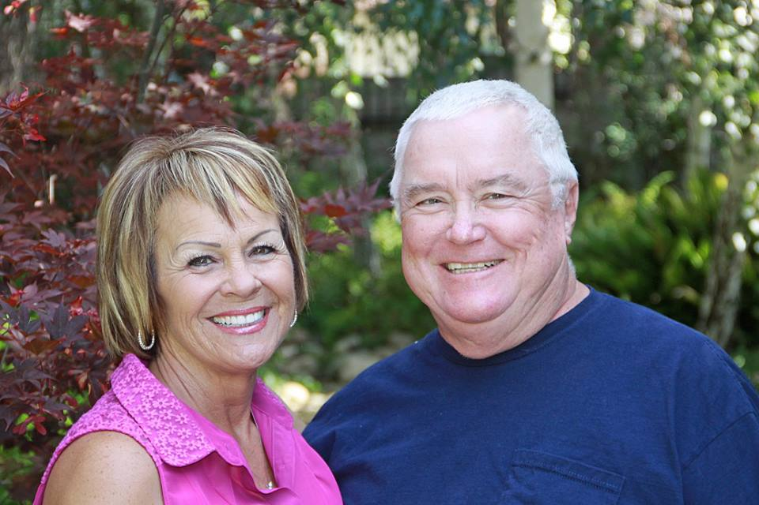**VOLUNTEERS…  
 A priceless treasure**

**If there is a Volunteer you would like to honor, please contact Roxanne in the office (805) 526-7577 or** [**svlc@dslextreme.com**](mailto:svlc@dslextreme.com)

Volunteers are worth their weight in gold. They share their time and talents without any compensation.

Our volunteer this month Barry Watters, is a face you see around church daily during the week and on Sundays. There is hardly anything that happens at SVLC that Barry is not involved in or volunteers to help with. His passion and willingness to serve is inspiring. You probably already know that he serves as a leader in our congregation as President of our church council. Did you know, that he also serves on property doing everything from spreading bark dust, changing light bulbs, cleaning up the grounds and making sure the toilet paper is stocked up. He and his beautiful wife Linda, organize our Lenten soup suppers, he recently helped at VBS, he works at Luther's Attic, helps change the banners in the sanctuary, greeter, usher, communion assistant and the list goes on and on. There are probably several things we missed.   
  
 I, Roxanne, would like to thank Barry for all that he has done to welcome me to SVLC. He makes me feel appreciated and valuable. He has blessed me with his knowledge of SVLC which made the transition for me working here much easier with the limited training I had. He came in every day to see if I needed any help. He is always cracking jokes and making me laugh first thing in the morning, he’s been my ray of sunshine each morning to start my day on a happy note. He does so much around here. **Anything** that needs attention, he is right on it.

Thank you Barry for your time and commitment to our congregation. Your willingness to use your gifts and abilities has strengthened the mission of this church.  You have also been an example of servant-leadership, giving and love.  For all your time, effort, hard work and prayers, please accept the thanks and appreciation of Shepherd of the Valley, its leaders and staff.  You both have truly been a blessing to this congregation.

**SVC Youth Calendar 2017**



**ELEMENTARY K-5th grade: **

**Summer Sunday Bible Fun –** We will meet in the purple room at the **10:30am service on all Sundays in August.**

**Reds BBQ Fundraiser –** Come have lunch or dinner at Reds BBQ on **Wednesday, August 16th anytime from 11am-9pm** and Reds will donate 20% back to the youth. Please bring the flier.

**Farewell BBQ 4 Marc** – August 20th at 12:30pm at church. Contact Roxanne in the office to let her know your coming.

**Spark –** We are on summer break until August 24th. On **August 24th** will resume Spark with a **Welcome Back BBQ and Farewell** to Marc from **5:30-8:30pm**. We will meet at the Honda’s house and the night will include swimming. The address is 3641 Highbury Ct, Simi Valley.

**Youth Room Maintenance Morning – Saturday, August 26th from 9am-12pm** at the church. All are welcome to help clean the nursery, Sunday School classrooms, and youth room.

**MIDDLE SCHOOL 6th-8th grade: **

**Acolytes** – Summer acolytes started on May 28th and will continue through August 20th. Fall acolytes will start on August 27th.

**Pool Party** – We will meet at 2007 Erin Ct, Simi Valley 93065 to go swimming (waterslide & spa) and have some snacks from **7:30-9pm on Thursday, August 3rd**.

**Reds BBQ Fundraiser –** Come have lunch or dinner at Reds BBQ on **Wednesday, August 16th anytime from 11am-9pm** and Reds will donate 20% back to the youth. Please bring the flier.

**Farewell BBQ 4 Marc** – August 20th at 12:30pm at church. Contact Roxanne in the office to let her know your coming.

**Welcome Back BBQ and Farewell** - to Marc from 5:**30-8:30pm on Thursday, August 24**. We will meet at the Honda’s house and the night will include swimming. The address is 3641 Highbury Ct. Simi Valley.

**Youth Room Maintenance Morning – Saturday, August 26th from 9am-12pm** at the church. All are welcome to help clean the nursery, Sunday School classrooms, and youth room

**HIGH SCHOOL 9th-12th grade:** 

**Red Cross Donation** – Come donate blood on Wednesday, August 9th from 2-8pm. Make an appointment by contacting Marc. This will help Marc with a potential scholarship with seminary.

**Reds BBQ Fundraiser –** Come have lunch or dinner at Reds BBQ on **Wednesday, August 16th anytime from 11am-9pm** and Reds will donate 20% back to the youth. Please bring the flier.

**Youth Group –** Youth group will resume on August 17th. We will meet from 7-9:30pm on August 17th to help treat the incoming 9th graders to a night of fun.

**Pool Party** – We will meet at 2007 Erin Ct, Simi Valley 93065 to go swimming (waterslide & spa) and have some snacks from **7:30-9pm on Thursday, August 3rd**.

**Houston National Youth Gathering Parent’s Meeting** – We will be having a meeting regarding the National Youth Gathering in Houston on **Sunday, August 13th at 11:30am-12:30pm** in the youth room at church for parents who were not able to go to the meeting in early June. All incoming 9th graders through 12th graders may attend this event which will take place June 26th through July 2nd 2018 in Houston. **Deposit of $150 is due by August 27th to hold a spot for the National Youth Gathering.**

**Farewell BBQ 4 Marc** – August 20th at 12:30pm at church. Contact Roxanne in the office to let her know your coming.

**Welcome Back BBQ and Farewell** - to Marc from 5:**30-8:30pm on Thursday, August 24**. We will meet at the Honda’s house and the night will include swimming. The address is 3641 Highbury Ct. Simi Valley.

**Youth Room Maintenance Morning – Saturday, August 26th from 9am-12pm** at the church. All are welcome to help clean the nursery, Sunday School classrooms, and youth room.

**College /Young –adult: **

**College/Young Adult Group** – We are on break until August. Please contact Amanda Lembke at [amandalembke@hotmail.com](mailto:amandalembke@hotmail.com) for more information.

**Red Cross Donation** – Come donate blood on Wednesday, August 9th from 2-8pm. Make an appointment by contacting Marc. This will help Marc with a potential scholarship with seminary.

**Reds BBQ Fundraiser –** Come have lunch or dinner at Reds BBQ on **Wednesday, August 16th anytime from 11am-9pm** and Reds will donate 20% back to the youth. Please bring the flier.

**Farewell BBQ 4 Marc** – August 20th at 12:30pm at church. Contact Roxanne in the office to let her know your coming.

**Welcome Back BBQ and Farewell** - to Marc from 5:**30-8:30pm on Thursday, August 24**. We will meet at the Honda’s house and the night will include swimming. The address is 3641 Highbury Ct. Simi Valley.

**Youth Room Maintenance Morning – Saturday, August 26th from 9am-12pm** at the church. All are welcome to help clean the nursery, Sunday School classrooms, and youth room.

**August 2017 Calendar**

***Sunday Monday Tuesday Wednesday Thursday Friday Saturday***

|  |  |  |  |  |  |  |
| --- | --- | --- | --- | --- | --- | --- |
|  |  | 1  9:00am Office Open  10:00am-SVLC/Attic  6:00pm-Stretch /Tone  6:00pm –AA (Library)  Covenant Players (Eichele Hall) | **2**  9:00am - Office Open  5:00pm – Community Dinner  (Samaritan Center)  Covenant Players   (Eichele Hall) | **3**  9:00am Office Open  10:00am-SVLC/Attic  5:00pm-Still Waters  Café  6:00pm-Stretch /Tone  7:00pm – Al Anon  Covenant Players (Eichele Hall) | 4  Covenant Players (EH) | **5**  8:00am-Al-anon 10:00am-AA/Library  Covenant Players (Eichele Hall) |
| **6**  9:00am-Traditional  10:30am-Contemporary  7:00pm-Al-anon  Covenant Players (Eichele Hall) | **7**  9:00am Office Open  6:00pm-Stretch/Tone  7:00pm-Al-anon  7:30pm-Al-ateen  Covenant Players (Eichele Hall) | **8**  9:00am Office Open 10:00am-SVLC/Attic 6:00pm-Stretch /Tone 6:00pm –AA (Library)  Covenant Players (Eichele Hall) | **9**  9:00am - Office Open  2:00pm – 8:00pm  **Blood Drive (EH)** | **10**  9:00am Office Open  10:00am-SVLC/Attic  5:00pm-Still Waters  Café Open  6:00pm-Stretch /Tone  7:00pm – Al Anon | **11**  9:00am- Office Open | **12**  8:00am-Al Anon  10:00am-AA-Library  **Image result for lutheran dodger game6:10pm – Lutheran  Dodger Game   (Dodger Stadium)** |
| **13**  9:00am-Traditional  10:30am-Contemporary   7:00pm-Al-anon  **BACK PACK   BLESSING**  at both services  Image result for kids backpack | **14**  9:00am-Office Open  6:00-Stretch /Tone  7:00-Al-anon  7:30-Al-Ateen | **15** 9:00am-Office Open10:00am- SVLC/Attic  6:00pm-Stretch / Tone 6:00pm –AA (Library)  7:00pm – SVLC Council  7:00pm –Happy Squares (Room 101) | **16**  9:00am - Office Open | **17**  9:00am-Office Open 10:00am-SVLC/Attic  5:00pm - Café Open  6:00pm-Stretch /Tone  7:00pm - Al Anon | **18**  9:00am-Office Open | **19**  8:00am-Al-anon  10:00am-AA Library |
| **20**  9:00am-Traditional  10:30am-Contemporary  **12:30pm –** **Marc’s   Going Away Party   (Eichelle Hall)**   7:00pm-Al-anon | **21** 9:00am-Office Open  6:00pm-Stretch/Tone 7:00pm-Al-anon  7:30pm-Al-ateen | **22**  9:00am - Office Open  6:00pm - Stretch/ Tone 6:00pm –AA (Library)  7:00pm – Youth Board | **23**  9:00am - Office Open | **24**  9:00am - Office Open   10:00am-SVLC/Attic  5:00pm-Café Open  6:00pm-Stretch /Tone7:00pm-Al-Anon | **25**  9:00am - Office Open | **26**  Image result for clean day at the church 8:00am - Al-anon   **9:00am**-noon – Church   Work Day 10:00am -AA-Library   **11:30am-Women’s Bible Study & Luncheon**  Image result for salsd |
| **27**  8:30 & 11:00am-   Traditional9:45am-Contemporary  7:00pm-Al-anon | **28**  9:00am-Office Open  6:00-Stretch /Tone  7:00-Al-Anon  7:30-Al-Ateen | **29**  9:00am-Office Open10:00am- SVLC/ Attic   6:00-Stretch/ Tone  6:00pm –AA (Library) | **30**  9:00am - Office Open | **31**  9:00am - Office Open   1 0:00am-SVLC/Attic  5:00pm-Café Open  6:00pm-Stretch /Tone  7:00pm-Al-anon |  |  |



**The Hannah Circle   
  
NO HANNAH CIRCLE IN AUGUST**

**Women’s Bible Study**

**For information on the Women’s groups, please contact Carol Ramsey @ 805-583-5532 or carolandken@roadrunner.com**

STAFF

**Rejoice Band Leader  
Steve Venz**

**Organist  
Saundra Carganilla**

**Parish Administrator  
Roxanne Yatman**[**svlc@dslextreme.com**](mailto:svlc@dslextreme.com)

**For prayer Requests:  
Marilyn Shapiro****m1shapiro@aol.com**

**Youth Director  
Marc Mohr**[**Marc.Mohr@dslextreme.com**](mailto:Marc.Mohr@dslextreme.com)

**Pastor  
Jennifer Chrien**  
[**Jenniferchrien@gmail.com**](mailto:Jenniferchrien@gmail.com)

**Elementary:**  
**Sunday – Sunday School @ 9:45 (No Sunday School during summer schedule.)  
Thursday – Spark (K-5th grade) 6:30-7:45 (Aug. – May)**

**College:**  
**College Hangout: 2nd and 4th Sunday of each month 8-10pm**

**Middle School:**  
**Wednesday – Confirmation 7:00-8:15pm (Sept.-May)  
Middle School Chat – 2nd & 4th Sunday @9:45am (Aug-May)**

**High School:**  
**Thursday – Youth Group 8:00-9:30pm**

**The Naomi Circle   
No circle until further notice.**

**Youth Board Members:**  
**Pastor Jennifer  
Marc Mohr – Youth Director  
Susan Caranchini  
Tom & Shelley McLain  
Jennifer Sterling  
Amanda Burns**

**Church Council Members:**  
**Barry Watters – President  
Julie Honda – Vice President  
Pastor Jennifer  
Lynn Squire – Secretary  
Shelley McLain – Treasurer  
Barbara Bruner  
Lori Lioy  
Tom McLain  
Nancy Mason  
Sue Holloway  
Pat Plyler**

**Women’s Board:**  
**Sue Holloway - President  
Barbara Swanson - Treasurer  
Linda Watters  
Jennifer Sterling  
Carol Ramsey  
Dianne Marshall  
Lisa Gearhart  
Melanie Addy  
Lynn Bonelli  
Kelli Stevens**