

**Like us on Facebook**  
www.facebook.com/SVLCSimi

**2017**

**March**

“Lenten Fasting: It’s Not a Diet”

In the church calendar, we have entered the season of Lent. Lent begins on Ash Wednesday (March 1st this year), and lasts forty days (forty-six, if you count the Sundays), until Easter.

Lent has traditionally been a season of penitence, reflection, and fasting. We remember how Jesus fasted in the wilderness for forty days after his baptism (Matthew 4, Mark 1, Luke 4). We prepare ourselves for the sacred days of Holy Week, especially the “Triduum”—the three days of Good Friday, Holy Saturday, and Easter Sunday. We reflect on the sinfulness and brokenness of humanity, a brokenness so deep that we would kill the Son of God, and a brokenness that can only be healed by Christ’s sacrifice on the cross.

Many people “give up” something for Lent, whether it’s chocolate or caffeine or gossiping. Some choose to “take on” a spiritual practice instead, like daily prayer. But for many Christians, Lent gets distorted by the secular culture around us. Lent becomes the do-over for your New Year’s resolutions that fell by the wayside in mid-January. Lent becomes the occasion for the latest diet. Fasting becomes self-centered and self-destructive, as we try to conform our bodies to what the world says is desirable.

Lenten fasting is not a diet. The point of Lent is not to lose weight, or get ready for swimsuit season, or make yourself look like some supposed “ideal.”

Here’s the truth: you are made in the image of God. Your face, your body, your form, right now, is in the image of God. Now that’s an ideal. God made you, and God looked at you, and God said, “This is very good.”

The world tells us we’re not good enough, and the world has a pile of remedies to sell us. “If you buy this product, try this diet, join this gym,” the world says, “Then you’ll be perfect. Then you’ll be happy. Then you’ll be beautiful.”

God looks at us, in all of our imperfections, and says, “This is very good.” God looks at our mistakes and our sin and our brokenness, our anger and fear and grief, and God loves every bit of it.

I know a pastor who recommends five countercultural ways to fast during Lent. Knowing that you already have the grace and love of God, perhaps one of these fasts may be meaningful for your spiritual life:

1. Fast from body-negative media: Mute the television during commercials. Fast from websites and tv shows that focus on weight and image. Stop reading body-negative magazines.

2. Fast from artificial sweeteners: Eat fruit. (Or real dessert with sugar in it!) Drink water. Sweet things are supposed to have calories. Our desire to satiate our sweet tooth without sacrificing our waistlines might come at great cost to our health.

3. Fast from unjust foods: This is basically impossible. But you might choose not to patronize restaurants that don’t pay a living wage. Or you might choose to abstain from factory-farmed meat. Or switch to some fair-trade products (even if paying more means consuming less).

4. Fast from mirrors: Again, basically impossible. But what better way to resist cultural messages that our worth is external?

5. Fast from disposables: Give up the paper cups, pizza boxes, and plastic take-out containers that deplete our earth’s resources and clog our landfills. Bring lunch from home. Take a reusable cup to the coffee shop.

Yours in Christ

Pastor Jennifer



Join us on a Roadtrip celebrating the 500th anniversary of the Reformation and learn about the impact of Martin Luther on the historical and modern church!  
  
Bishop Guy Erwin will carry Luther's message all around the Southwest California Synod with a series of six paired lectures, presented on various Saturdays from September 2016 to July 2017.   
  
For each session, the first lecture will be an introduction to Martin Luther. Lunch will be served, followed by an in-depth lecture about Luther's teachings. Come hear one, or come hear all; the in-depth lecture will be different every time!

Each Reformation Roadtrip event will be held from 10:00 a.m to 2:30 p.m. The cost is $10 per event, or $50 for all six. Please bring payment in cash or check the day of the event. Checks should be made out to the Southwest California Synod.  
  
To make your reservations for one or more Reformation Roadtrip events, please contact Jason Ramirez at [**jramirez@socalsynod.org**](mailto:jramirez@socalsynod.org).

**Reformation Roadtrip Locations**

|  |  |
| --- | --- |
| November 19, 2016  First Lutheran Church  2900 West Carson Street  Torrance, CA 90503 | March 25, 2017  Emmanuel Lutheran Church  6020 Radford Avenue  North Hollywood, CA 91606 |
| January 21, 2017  Hill Avenue Grace Lutheran Church  73 North Hill Avenue  Pasadena, CA 91106 | May 13, 2017  Ascension Lutheran Church  1600 East Hillcrest Drive  Thousand Oaks, CA 91362 |
| http://files.constantcontact.com/1ed75ba9001/dbd452b5-e1ea-4550-9bf5-e78686628b8d.jpg | July 15, 2017  Mt. Carmel Lutheran Church  1701 Fredericks Street  San Luis Obispo, CA 93405 |



LIBRARY NEWS

**We are now in Lent. A time to look back on our lives, admit to our failures, and make an effort to do more to be the person God wants us to be. We no longer give up candy or television or some other indulgence. Instead we try to make amends, and to give up our greed, our selfishness, our conceit.  
  
This month the book cart will feature helpful reading materials to assist you in recognizing your sins and hopefully to overcome them. It will also contain books on the disciples, showing us more about these 12 interesting men during Jesus’s ministry and the last days of Jesus’ life.   
  
For the children, there will be Easter stories for them to read or for you to read to them.  
  
Please take the time to browse both the cart and the shelves inside the Library.**

welcome

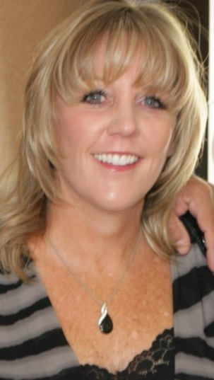

Roxanne Yatman started working as our Parish Administrator in February 2017. Roxanne is married to Atilla and has a 25 year old daughter, Nicole. Roxanne is from California and loves to spend time at her home on the Aegean Coast of Turkey spreading the good news of the Lord in a 98% Muslim nation. Most of the time she will be the voice you hear when you call and the first face you see when you enter our office. She is here to answer any questions you might have.

You can contact Roxanne at [**svlc@dslextreme.com**](mailto:svlc@dslextreme.com)

**FAITH IN ACTION**



***Dear friends and family, if there are friends and loved ones whom you would like to have prayers for, or military persons on active duty, please contact the church office at 526-7577and we will list them in our bulletin and newsletter.***

REMEMBER IN PRAYER…Good Shepherd Lutheran School youth and church leaders.

***Undergoing cancer therapy***

Mike Denmark (*Cathie Badillo’s brother-in-law*), Wendy Bealliu, Brian Apuzzo, Barbara Corrigan

***Under convalescent or hospice care***

**Please contact the church office 526-7577 with any updates you may have on persons listed for prayers. *Thank you***

Rev. James Sherrill & Mae Maddoax

*(Cathie Badillo’s aunt & uncle),* Craig Wells,

Justin Scholberg (*Corrine Stevenson’s father*),

Jean Stevenson (*Pastor Gary’s mother*).

***Undergoing surgery, various tests, treatments, recuperating and continued comfort***

Jeanne Shafer, Kent Keith, Jean Schlosser, Betsy Hospodar, Shirley Ruben, Brett Lea (*Irene Tangren’s grandson*), Angel Rodriquez, Joyce Bruce, Charlotte Weldon, Donna Ritter.

***Military Recognition:***

We would like to honor our military by recognizing family members from our church currently serving. If you have a family member now serving in the military, please call Sally Valderrama @ 805-527-4061 or Email (Sally.Valderrama@gmail.com) for further details.

***The congregation of Shepherd of the Valley Lutheran Church thanks you for your service***

Y.I.M.A.H. Potluck Luncheon

(**Y**oung **I**n **M**ind **A**nd **H**eart 50yrs. and over)



This event is typically for seniors 50yrs of age or over but…**Hey** **who’s counting**, come and join in any third Thursday of the month. For further information please call: Edith Engemann 805-526-9020 **or** the church office 526-7577.

MC900047820[1]***Samaritan Center of Simi Valley***

Shepherd of the Valley Lutheran Church serves a meal to the less fortunate at the ***Samaritan Center*** (located at 280 Royal Ave) on the **1st Wednesday of every month.**

**We need volunteers to buy and deliver food** to the Samaritan Center,

**AND…serve food or donate money**

If you would like to help, please contact Yvonne Baird at 584-2521. Thank you for your prayers





**As we go through the Lenten season and with Easter itself fast approaching, April 16th, let’s not forget the significance and true meaning of Lent which is, in part, the time to reflect upon and remember the Sacrifices, Death and Resurrection of our Lord and Savior Jesus Christ and guiding us forward to Good Friday and Easter Sunday. During the Lenten season, many people abstain from eating certain foods and others from engaging in particular activities. If you are going to give up something for Lent, try not to let it be your participation in SVLC’s scrip program! We continue to offer a wide selection of gift cards for many of your favorite department stores, restaurants, grocery stores, specialty shops and gasoline stations. So if you patronize a particular store that participates in our scrip program, why not purchase scrip gift cards and make your shopping experience faster and easier at the same time help support Shepherd of the Valley with a percentage of each and every gift card you purchase being returned to our church. It’s a win/win situation for both you and SVLC! If you are planning to buy something particular for Easter, or perhaps an anniversary, birthday or some other special occasion, remember to ORDER and BUY EARLY so that we can have your gift cards ready when you need them! We have recently been advised that the scrip center where we purchase our scrip will be closed for Spring Break the week before Easter to give their team members a chance to spend some well-deserved quality time with their families and as a result we will not be able to order scrip that week. The scrip center does a fantastic job in processing all of our orders, making sure they are accurate, processed quickly and delivered on time. So again, remember to ORDER and BUY EARLY.**

**In His Service, Marvin and Jenny Kidd, SVLC Scrip Committee**

Invites ***you*** to share a ***free*** community meal every **Thursday at 5:00 p.m.**

The café is located at 4191 Cochran Street.

For more information please call **805-526-7577**

“A dining service to those who are suffering economic hardship,

homelessness or who are lonely and wish to have a dining companion”

MCj04355580000[1]Amenities at the café:

* **Mealtime is served beginning at 5:00p.m.–6:30 p.m. every Thursday.**
* Fresh home cooked meal served in a family atmosphere with home style table settings.
* To-go snack bags are offered.
* Highchairs and booster seats are available for the younger family members.
* There are wheelchair accessible entrances and bathrooms available.
* Prayer requests can be satisfied.

**Sport Equip.etc.**  
S

**PLEASE…HELP SUPPORT GOOD SHEPHERD LUTHERAN SCHOOL At…**

MC900351209[1]**Luther’s Attic…**a thrift store which is located in the city of Moorpark

MC900383832[1]189 E High Street

MC900057021[1]MC900113476[1]MC900057304[1]Monday – Saturday 10AM – 4PM

(805) 523-7188

luthersatticmoorpark.com

**Give donations, shop and/or volunteer your time!!**

It all helps the Christian school ministry here in Simi Valley.



A big thank you for the donations. I have enough to make up six gift bags.

**interface 2017**



**ELEMENTARY K-5th grade: **

**Sunday School –** Meets in the purple room every Sunday @ 9:45am.

**Spark –** Spark will meet from 6:30-7:45pm on Thursdays except on March 2nd and March 30th

**Ash Wednesday Service** – Wednesday, March 1st @ 7-8pm.

**Lent -** During the season of Lent from (March 8th through April 5th) we will have a Bible study at 5pm, Soup Supper at 6pm, and Meditative Prayer Service at 6:45pm. Parents and youth are encouraged to come**.**

**Big Z’s** – We will meet at Big Z’s on Thursday, March 23rd from 6:30-7:45pm. Cost is $7 for pizza, a drink, and 16 tokens. If you’d like more tokens please bring extra money.

**MIDDLE SCHOOL 6th-8th grade:** 

**Confirmation** – Confirmation will take place every week in March except on March 30th. **On March 1st instead of confirmation I’d like all the confirmation students to attend the Ash Wednesday service from 7-8pm.**

**Lent –** During the season of Lent from (March 8th through April 5th) we will have a Bible study at 5pm, Soup Supper at 6pm, and Meditative Prayer Service at 6:45pm. Parents and confirmation students are encouraged to come to the Soup Supper at 6pm and parents to the Meditative Prayer Service at 6:45pm while the students are in confirmation.

**Middle School Chat** – We will have middle school chat on **Sunday, March 12th and on Sunday, March 26th at 9:45am**. We will walk to Taco Bell on March 12th and to Donut Time on March 26th. Please bring a few dollars for breakfast.

**The Compassion Experience -** We will be going to The Compassion Experience on **Sunday, March 19th from  
 1-4pm**. Cost is FREE. Please sign-up by March 15th.

**HIGH SCHOOL 9th-12th grade:** 

**Youth Group –** Youth group will take place in the youth room at church on Thursdays from 8-9:30pm. No youth group on March 2nd & March 30th.

**Ash Wednesday Service** – Wednesday, March 1st @ 7-8pm.

**Lent -** During the season of Lent from (March 8th through April 5th) we will have a Bible study at 5pm, Soup Supper at 6pm, and Meditative Prayer Service at 6:45pm. Parents and youth are encouraged to come**.**

**The Compassion Experience** – We will be going to The Compassion Experience on **Sunday, March 19th from 1-4pm**. Cost is FREE. Please sign-up by March 15th.

**Western States Youth Gathering –** This event will be held at California Lutheran University **June 28th – July 2nd**. This event is open to all incoming 9th graders through all outgoing 12th graders. Please let Marc know if your child can attend.

**College /Young –adult: **

**College/Young Adult Group** – **Sunday, March 12th** (with Rabbi Michele) and on **March 26th** at the Mohr’s house.

**Purim Service –** Meet at Congregation B’nai Emet at 7pm on Friday, March 10th. The address is 9 West Bonita Dr. Simi Valley, 93065.

**Ash Wednesday Service** – Wednesday, March 1st @ 7-8pm

**Lent -** During the season of Lent from (March 8th through April 5th) we will have a Bible study at 5pm, Soup Supper at 6pm, and Meditative Prayer Service at 6:45pm.

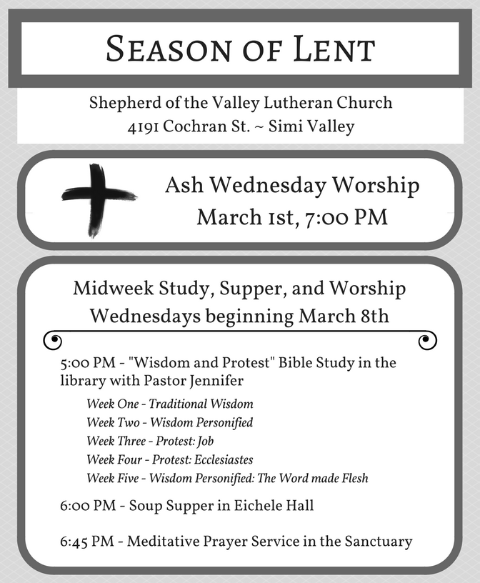

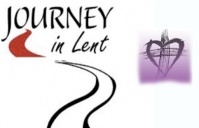**March 2017 Events**

Sunday Monday Tuesday Wednesday Thursday Friday Saturday

|  |  |  |  |  |  |  |
| --- | --- | --- | --- | --- | --- | --- |
|  |  |  | **1**  7:30-Ashes to Go  9:00-Office open  10:00 SVLC/Attic  5:00- Community Dinner-Samaritan Center  7:00- Simi Church  **7:00-Ash Wed.  Service** | **2**  9:00-Office open  10:00-SVLC/Attic  5:00-Café Open  6:00-Stretch /Tone  6:00- Girl Scout Award  7:00-Al-anon | **3**  9:00-Office  6:00-Boy Scout #3642  **8:00-P.A.D.S.** | **4**  8:00-Al-anon  10:00-AA-Library |
| **5**  9:00-Traditional  9:45-Contemporary  9:45-Sunday School  K-5th grades  11:00-Traditional  7:00-Al-anon | **6**  9:00-Office open  6:00-Stretch /Tone  7:00-Al-anon  7:30-Al-ateen | **7**  9:00-Office open  10:00 SVLC/Attic  5:00-American  Heritage Girls  6:00-Stretch / Tone  6:00-AA  7:00-Happy Squares | **8**  9:00-Office open  10:00 SVLC/Attic  5:00-Bible Study  6;00-Soup Supper  6:45-Worship  7:00-Confirmation | **9**  9:00-Office open  10:00-SVLC/Attic  10:00-NAOMI  Women’s study  5:00-Café Open  6:00-Stretch /Tone  6:30**- SPARK**  7:00-Al-anon  8:00-Youth Group | **10**  9:00-Office  **8:00-P.A.D.S.** | **11**  10:00-AA-Library |
| **12**  9:00-Traditional  10:00-Contemporary  9:45-Sunday School  K-5th grades  9:45-Middle  School Chat  11:00-Traditional  7:00-Al-anon | **13**  9:00-Office open  6:00-Stretch /Tone  7:00-Al-anon  7:30-Al-ateen | **14**  9:00-Office open  10:00 SVLC/Attic  6:00-Stretch / Tone  6:00-AA  6:30-SVCC Prayers  7:00-HANNAH  Women’s Study | **15**  9:00-Office open  10:00 SVLC/Attic  5:00-Bible Study  6;00-Soup Supper  6:45-Worship  7:00-Confirmation | **16**  9:00-Office open  11:30-**Y.I.M.A.H**. –  Potluck Seniors 50+  5:00-Café Open  6:00-Stretch /Tone  6:30-SPARK  7:00-Al-anon  8:00-Youth Group | **17**  9:00-Office  **8:00-P.A.D.S.** | **18**  6:30-Movie Night  8:00-Al-anon  10:00-AA-Library  10:00-SVLC @ Attic |
| **19**  9:00-Traditional  9:45-Contemporary  11:00-Traditional  7:00-Al-anon | **20**  9:00-Office open  6:00-Stretch /Tone  7:00-Al-anon  7:30-Al-ateen | **21**  9:00-Office open  10:00 SVLC/ Attic  5:00-American  Heritage Girls  6:00-Stretch/ Tone  6:00-AA  7:00-SVLC Council | **22**  9:00-Office open  10:00 SVLC/Attic  5:00-Bible Study  6;00-Soup Supper  6:45-Worship  7:00-Confirmation | **23**  9:00-Office open  10:00-SVLC/Attic  5:00-Café Open  6:00-Stretch /Tone  6:30**- SPARK**  7:00-Al-anon  8:00- **Youth Group** | **24**  9:00-Office  **8:00-P.A.D.S.** | **25**  8:00-Al-anon  10:00-AA-Library |
| **26**  9:00-Traditional  9:45-Contemporary  11:00-Traditional  7:00-Al-anon | **27**  9:00-Office open  6:00-Stretch /Tone  7:00-Al-anon  7:30-Al-ateen | **28**  9:00-Office open  10:00 SVLC/ Attic  6:00-Stretch/ Tone  6:00-AA  7:00-Youth Board | **29**  5:00-Bible Study  6;00-Soup Supper  6:45-Worship | **30**  5:00-Café Open  6:00-Stretch /Tone  6:30**- SPARK**  7:00-Al-anon  8:00- **Youth Group** | **31**  **8:00-GSLS Dinner Auction**  **8:00-P.A.D.S.** |  |





**Youth Board Members:**  
**Pastor Jennifer  
Marc Mohr – Youth Director  
Susan Caranchini  
Tom & Shelley McLain  
Jennifer Sterling  
Amanda Burns**

**Church Council Members:**  
**Barry Watters – President  
Julie Honda – Vice President  
Pastor Jennifer  
Lynn Squire – Secretary  
Shelley McLain – Treasurer  
Barbara Bruner  
Lori Lioy  
Tom McLain  
Nancy Mason  
Sue Holloway  
Pat Plyler**

**The Hannah Circle   
Tuesday, March 14th at 7:00pm, at the home of Diane Marchall (3807 Lucas St.). We are starting a new study from the Women of Faith series “Living Above Worry and Stress”**

**The Naomi Circle   
Thursday, March 9th at 10:00am, at the home of Leona   
Stewart (2158 Ardenwood)**

**Women’s Bible Study**

**For information on the Women’s groups, please contact Carol Ramsey @ 805-583-5532 or carolandken@roadrunner.com**

**Youth Director  
Marc Mohr**[**Marc.Mohr@dslextreme.com**](mailto:Marc.Mohr@dslextreme.com)

**Pastor  
Jennifer Chrien**  
[**Jenniferchrien@gmail.com**](mailto:Jenniferchrien@gmail.com)

**Rejoice Band Leader  
Steve Venz**

**Organist  
Saundra Carganilla**

**For prayer Requests:  
Marilyn Shapiro  
m1shapiro@aol.com**

**Parish Administrator  
Roxanne Yatman**[**svlc@dslextreme.com**](mailto:svlc@dslextreme.com)

STAFF

**Women’s Board:**  
**Sue Holloway - President  
Barbara Swanson - Treasurer  
Linda Watters  
Jennifer Sterling  
Carol Ramsey  
Dianne Marshall  
Lisa Gearhart  
Melanie Addy  
Lynn Bonelli  
Kelli Stevens**

**College:**  
**College Hangout: 2nd and 4th Sunday of each month 8-10pm**

**Elementary:**  
**Sunday – Sunday School @ 9:45  
Thursday – Spark )K-5th grade) 6:30-7:45 (Aug. – May)**

**Middle School:**  
**Wednesday – Confirmation 7:00-8:15pm (Sept.-May)  
Middle School Chat – 2nd & 4th Sunday @9:45am (Aug-May)**

**High School:**  
**Thursday – Youth Group 8:00-9:30pm**