

**Saturday, October 7th Simi Hills Golf Course  
First Tee Time 11:00 AM  
3-Hole Putting Contest   
Prizes – Raffle – Awards**

**Gold Sponsor - $2,000.00** **Birdie Sponsor - $500.00**(1) Foursome, Sign Sponsor (1) Individual Golfer, Sign Sponsor  
20 Tickets for Prizes 5 Tickets for Prizes

**Silver Sponsor - $1,500.00** **Sign Sponsor - $250.00**(1) Foursome, Sign Sponsor  
15 Tickets for Prizes **Individual Golfer - $125.00  
 $400.00 for Foursome**

**Bronze Sponsor - $1,000.00**(1) Foursome, Sign Sponsor  
10 Tickets for Prizes



**Free Lunch After Golf  
Bucket of Balls for Driving Range  
Scramble Golf Tournament  
Trophies for 1st and 2nd Place  
  
Raffle to Follow After  
Last Golfer is in**

**Simi Hills Golf Course  
5031 Alamo Street  
Simi Valley, CA 93063  
www.simihillsgolf.com**

**www.gsls-simi.com**

**Sam Reid**

**(805)551-0145**

**samreid99@sbcglobal.net**

**Tim Dahme**

**(805)428-3894**

**tim@dahmehvac.com**

**SAVE THE DATE**

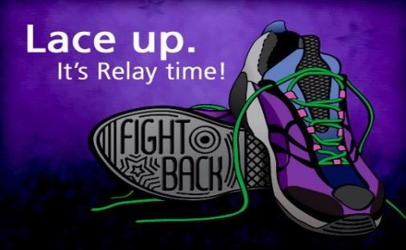

**RELAY FOR LIFE** - **October 21 & 22, 2017,** is the signature fundraiser for the American Cancer Society. Register to join our team or donate @ **main.acsevents.org/goto/SVLC2017.** Volunteers give of their time and effort because they believe it's time to take action against cancer.

Join us at these events to bring communities together to remember loved ones lost, honor survivors of all cancers, and raise money to help the American Cancer Society make a global impact on cancer.

Date: Sunday, OCTOBER 29TH

Time: 6:00pm – 8:00pm

Place: In Eichele Hall



And Pumpkin Carving



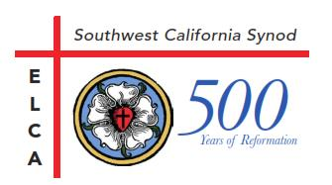 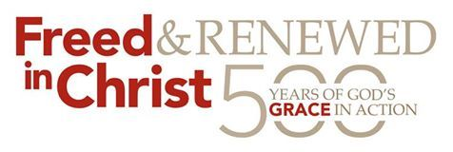

*Every day, life presents opportunities to help someone in need.  
Dare to be generous.*

SVLC’s Christmas Shoppe

Reforming Forward: On October 28th at 4:30pm, the Channel Islands Conference of the Southwest California Synod will host a 500th Anniversary Reformation Worship Service in Samuelson Chapel at California Lutheran University. Join us for a service commemorating the history of the Protestant Reformation and celebrating the many ways the church continues to reform today and into the future.

The Christmas Shoppe is for underprivileged families of Simi Valley. It is held on December 9th and it is private invitation only. But, if you would like to help, we need volunteers, bags of food (Canned cranberry, Instant mashed potatoes, Stuffing) and $25 grocery gift cards for the families to buy meat.

**Christmas Shoppe** is Dec. 9th, but there are many things we need to prepare beforehand.  Shepherd of The Valley participates by giving a bag of food along with a $25 grocery gift card to the invited guests.  Those who receive an invitation are the underprivileged of Simi Valley who might not be able to give their children something for Christmas.  We are currently collecting food for the bags and our biggest need is boxes of instant mashed potatoes, boxes of stuffing, Turkey gravy, and canned cranberries.  These items can be purchased at the 99 cent store or the Dollar Tree. There is a



box in the Narthex for the donations. We are also in need of $25 grocery store gift cards.  You can buy cards at the Scrip table and you will be benefiting both our church and Christmas Shoppe.  All items need to be collected by the Sunday, Nov. 26th.  Thank you so much for your help.