……dine-in……..take-out……or have your food delivered
Phone (805) 581-0976 FAX (805) 581-6387
C
L
A
S
S

Join us to help raise funds for our youth at:
RED’S BBQ & Grillery Night

Wednesday, August 16th
11:00 am – 9:00 pm
20% of your food bill will go to:

Shepherd of the Valley
Youth Group

Not valid with any specials, coupons, or discounts. Flier must be present when ordering.
Flier may not be passed out in the restaurant or the restaurant parking lot.

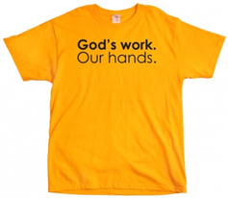
Click here
Register to join our team or donate

September 10, 2017
October 21 & 22 2017
God’s work Our hands Sunday - is an opportunity to celebrate who we are as the Evangelical Lutheran Church in America – one church, freed in Christ to serve and love our neighbor. Day of service is Sunday Sept. 10. Mark your calendars today!
T-shirts for God's Work, Our Hands Sunday with our church name on it. $10. Must order by August 13th. See Julie on the patio or contact her at juliamhonda@gmail.com

Click here
Register to join our team or donate

October 21 & 22 2017
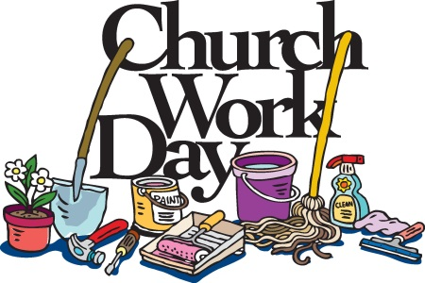

Saturday, Aug 26, 9am-Noon
What’s it For?
- The Nursery
- The blue and purple SS Rooms and supply closet (between the Nursery and Library)
- The Youth Room (above the Office)
Who’s Invited?
Anyone willing to help clean, organize, de-clutter, and/or fix things (or is just curious about what we want to get rid of!)
Come for just an hour or all three – Any help appreciated!
Feel free to bring your kids to play in the playground
(or we can put them to work? ;-)

Examples of projects we envision:
Washing walls and windows; Cleaning/sorting the Nursery toys; Organizing the SS supply closet; Fixing/Moving a ping-pong table; Moving stuff to the dumpster; Cleaning windows and/or blinds; Bring your favorite vacuum to help in general cleaning…

Have questions or suggestions?
Feel free to contact Julie, Julie.ostberg@yahoo.com
cell: 716-308-5473

Women’s Summer Bible Study and Salad Luncheon
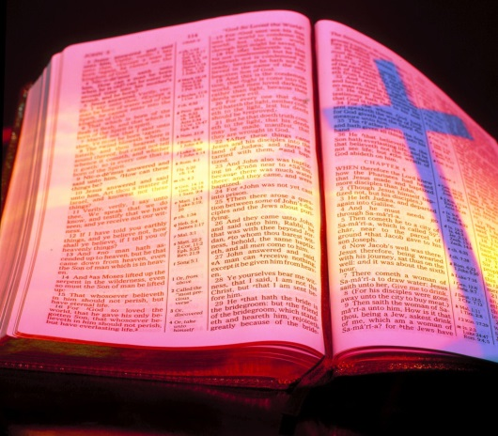
If you need a ride, email or call Carol Ramsey (805) 583-5532

Please join your Sisters in Christ for fellowship, a potluck Salad lunch and a bible study
“Taking it Slow”

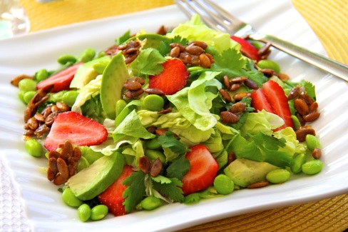

Date: August 26th
Time: 11:30am
Place: Home of Lisa Darin
907 Oakmont Ct.
Simi Valley, CA 93065

